10. SINIF, 2. FİZİK SINAVI 5 9

1

2

3

4

6

7

8

10

11

1

2

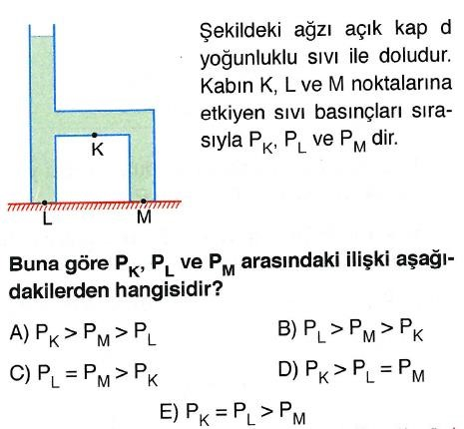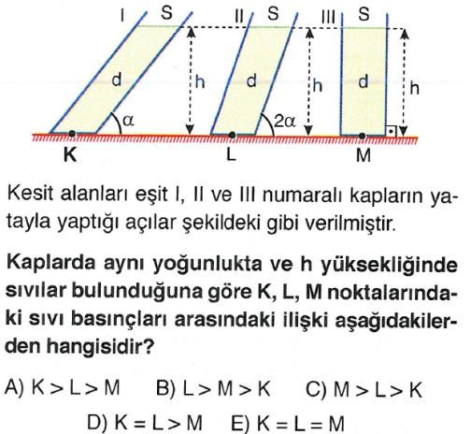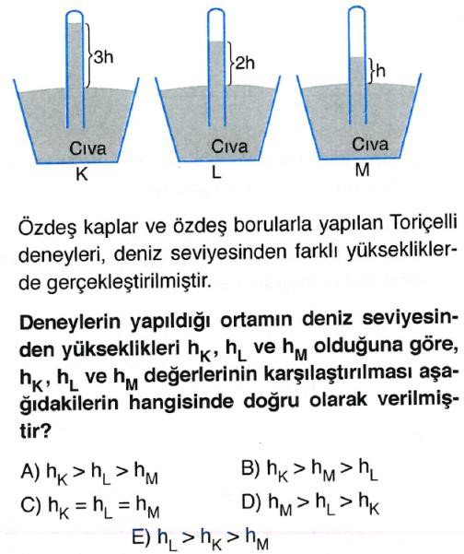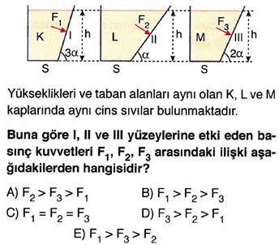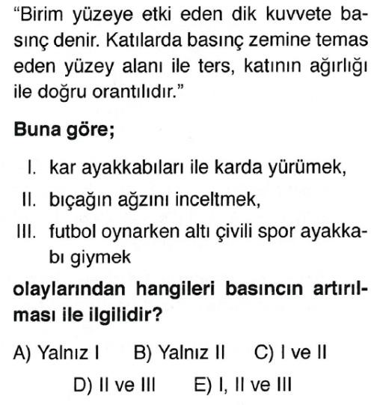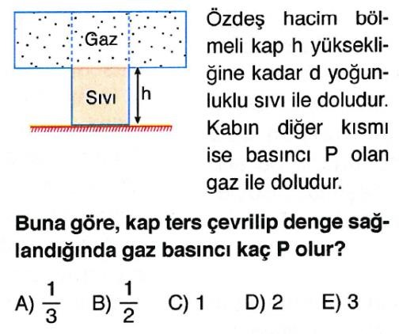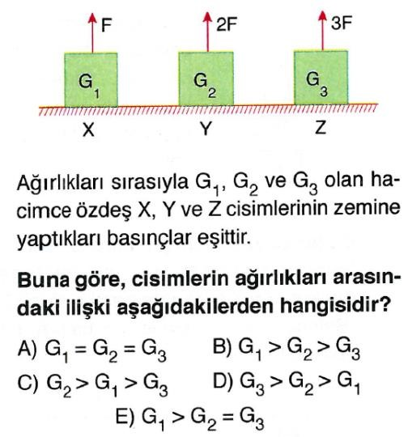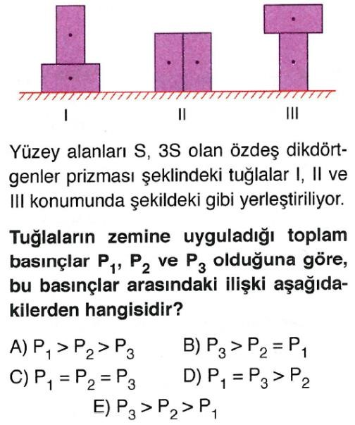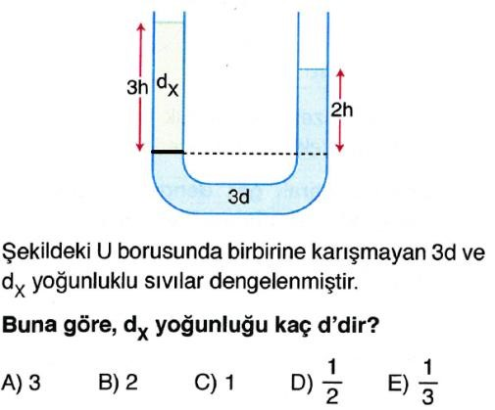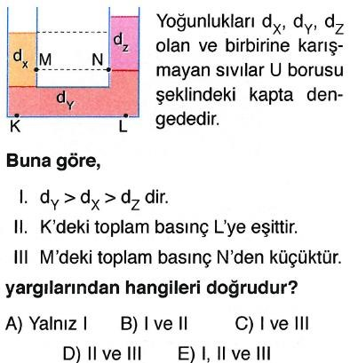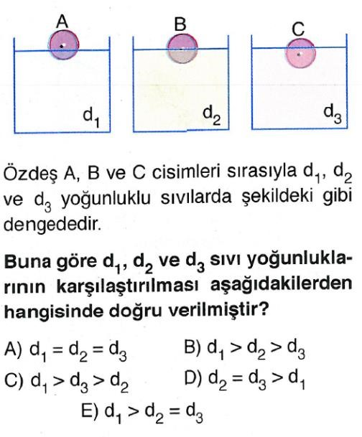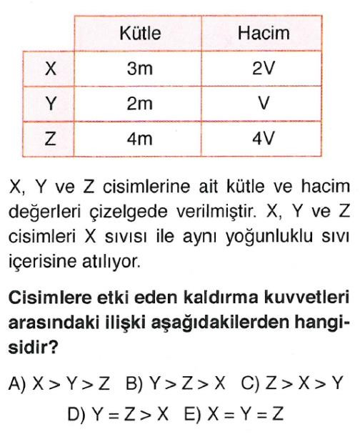

13 17 21

14

15

16

18

19

20

22

23

24

25

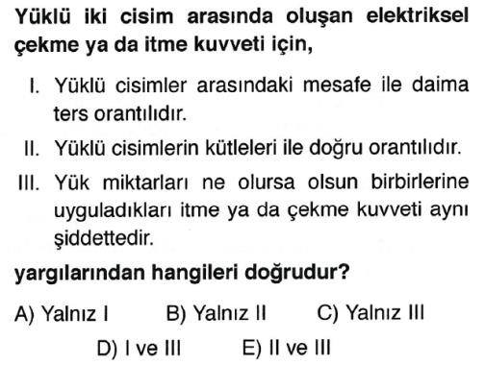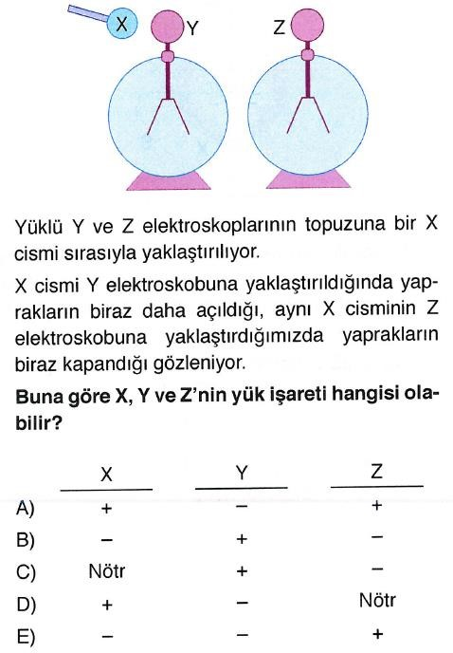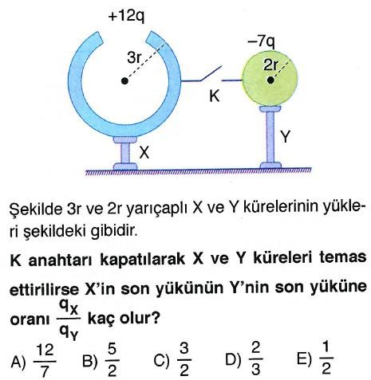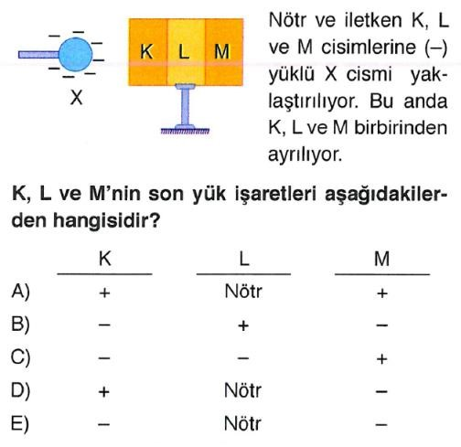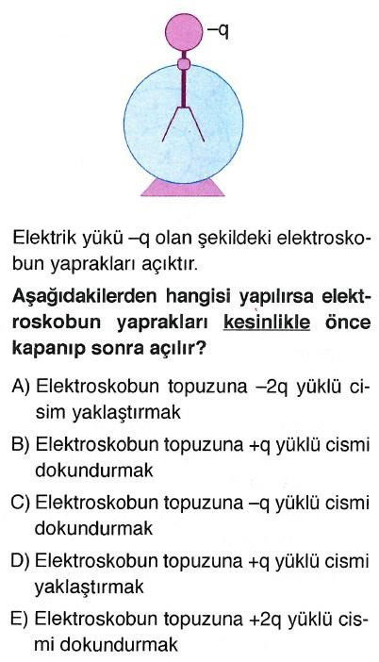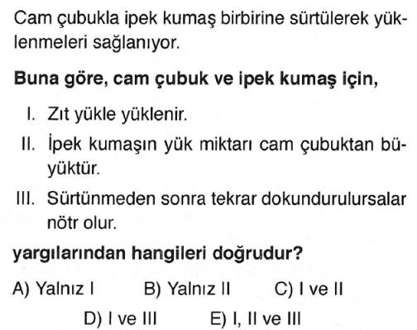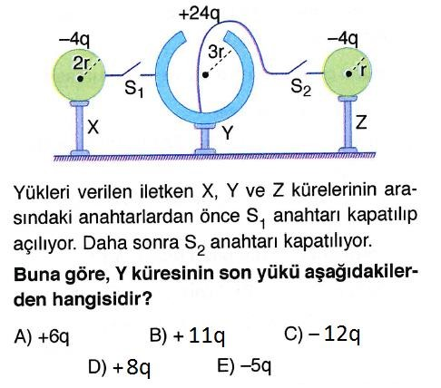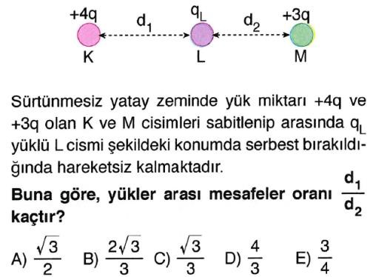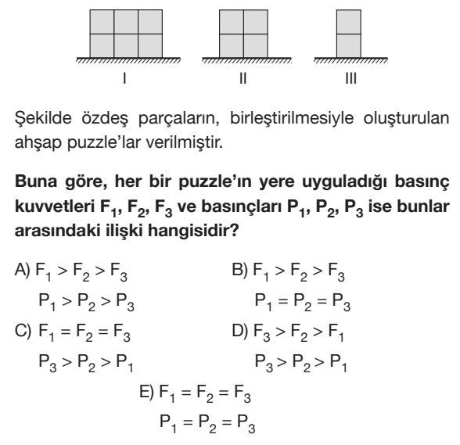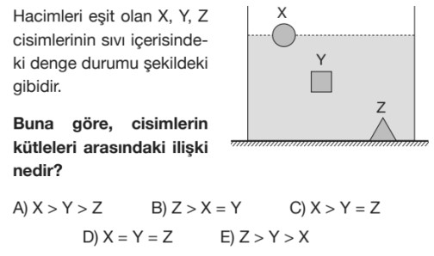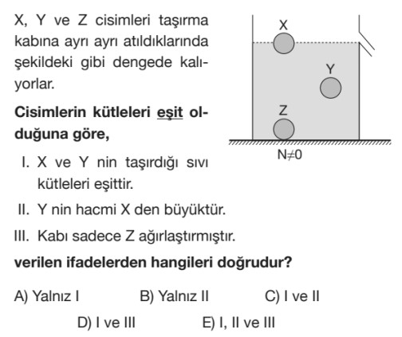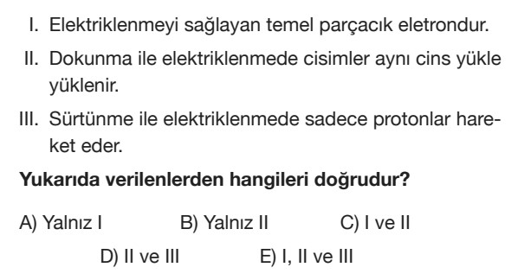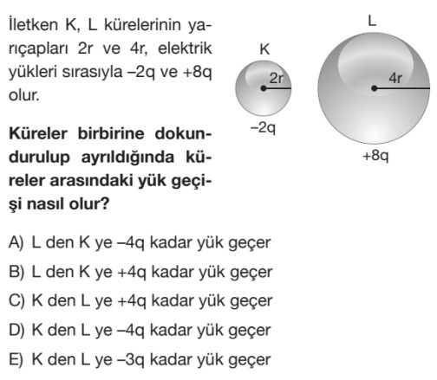

# CEVAP ANAHTARI

|  |  |  |  |  |  |
| --- | --- | --- | --- | --- | --- |
| 1 | A | B | C | D | E |
| 2 | A | B | C | D | E |
| 3 | A | B | C | D | E |
| 4 | A | B | C | D | E |
| 5 | A | B | C | D | E |
| 6 | A | B | C | D | E |
| 7 | A | B | C | D | E |
| 8 | A | B | C | D | E |
| 9 | A | B | C | D | E |
| 10 | A | B | C | D | E |
| 11 | A | B | C | D | E |
| 12 | A | B | C | D | E |
| 13 | A | B | C | D | E |
| 14 | A | B | C | D | E |
| 15 | A | B | C | D | E |
| 16 | A | B | C | D | E |
| 17 | A | B | C | D | E |
| 18 | A | B | C | D | E |
| 19 | A | B | C | D | E |
| 20 | A | B | C | D | E |
| 21 | A | B | C | D | E |
| 22 | A | B | C | D | E |
| 23 | A | B | C | D | E |
| 24 | A | B | C | D | E |
| 25 | A | B | C | D | E |