YILI ………………. ORTAOKULU II. DÖNEM 6. SINIFLAR 1. YABANCI DİL SINAVI

Name Surname: Class:6/ No:

**A-Aşağıdaki resimlerin altına kelimeleri doğru olacak şekilde yerleştiriniz (3x6=18 p)**

**[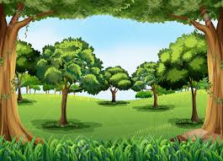](https://www.hangisoru.com)seaside - mountain - tent – forest– river–diving**

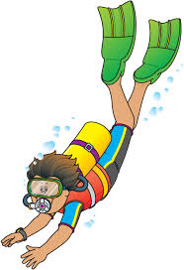



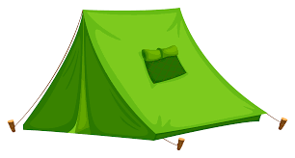**[](https://www.hangisoru.com)**

**B- Aşağıdaki boşlukları was ya da were ile doldurunuz. (3x5=15 p)**

1-They ____________ in Erzurum between 2010 and 2017.

2- Where __________ Ayşe yesterday?

3- I andmyfriends ____________ shortlastyear.

4- I ___________ 10 yearsoldtwoyearsago.

5- Hakan and Mert __________ at thecircuslastweek.

**C- Aşağıdaki resimlerin altına uygun meslek adlarını yerleştiriniz. (8x2=16 p)**

**baker – greengrocer - mechanic – hairdresser – tailor – architect - cook - waiter**

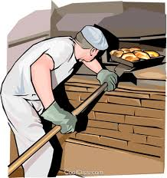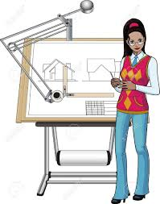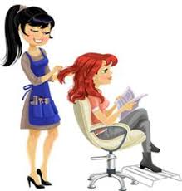

________ ____________ ______________ _____________

**[](https://www.hangisoru.com)**

**[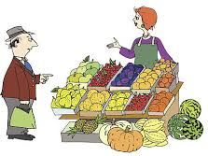](https://www.hangisoru.com)[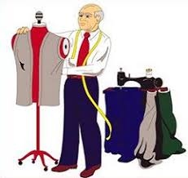](https://www.hangisoru.com)**

_____________ _______________ ____________ _____________

**D- Aşağıdaki cümlelerde parantez içindeki fiillerin geçmiş zaman formunda yazınız.(7x2=14 p)**

1- Tuğba _____________ (get) up at 7.35 yesterday.

2-She _____________ (wash) her face.

3- She _____________ (drink) milk at breakfast.

4- She _____________ (go) toschool at 8:00

5- She _____________ (play) volleyball at school.

6- She ______________ (do) her homeworkafterschool.

7- She ______________ (watch) Tv in theevening.

**E- Aşağıdaki metni okuyunuz ve altındaki ifadelerin karşısına True (Doğru) ya da False (Yanlış) yazınız.(3x5=15 p)**

Hi, I am Nihat. I was in Antalya lastsummer. Itwasgreatholiday, but theweatherwasvery hot. I wenttherewithmyfamily. Westayed at a hotel. Wewentsightseeing in thecity. Wevisitedthemuseumand Kaleiçi. My motherdidshoppingwithmysister. Weatedeliciousfood at restaurants. Weswam at Konyaaltı Beach. I triedwindsurfing. Finally, weclimbedOlympos Mountain.

1-Nihatdidn’tclimbto Olympos Mountain. _________

2- Theystayed at a hotel _________

3-Theweatherwasvery hot _________

4-They didn’tgothemuseum _________

5- Nihat and his familyswam in thesea. _________

**F- Aşağıdaki tarihler ile yazılışlarını eşleştiriniz.(5x2=10p)**

a) thesecond of April twothosandandsix ___ 1- 25th May, 1997

b) thetwenty-third of May nineteenninety-six ___ 2- 2nd April, 2006

c) thethird of April twothousandandsix ___ 3- 1st April, 2006

d) thetwenty-fifth of May nineteenninety-seven ___ 4- 23rd May, 1996

e) thefirst of April twothousandandsix ___ 5- 3rd April, 2006

**G- Aşağıdaki sorular ile cevapları eşleştiriniz. (4x2=8 p)**

___ 1-What didyou do lastnight? a) No, I didn’t.

___ 2-When wereyouborn? b) I was in Antalya.

___ 3- Didyougotoschoolyesterday? c) in 2006

___ 4- What is yourmother’sjob? d) I studiedmaths.

___ 5- Wherewereyou on holiday? e) She is a housewife.

**H- Aşağıdaki soruları kendinize göre cevaplayınız. (2x2=4p)**

1- Whatdidyoudrink at breakfast in themorning?

2- Didyouwatch TV lastnight? [**https://www.HangiSoru.com**](https://www.HangiSoru.com/)