**NAME/SURNAME(AD/SOYADI):……………………………………….. GRADE: 5-A NUMBER:………**

**1.BÖLÜM Complete the sentences with “CAN” “CAN’T”. (10 points)**

|  |  |  |  |  |
| --- | --- | --- | --- | --- |
|  | RIDE A BCYCLE | SWIM | READ ABOOK | PLAY TENNIR |
| AYŞE | sad smiley | http://designsinmylocket.files.wordpress.com/2012/12/smiley-face.jpg?w=1200 | http://designsinmylocket.files.wordpress.com/2012/12/smiley-face.jpg?w=1200 | sad smiley |
| DENİZ | http://designsinmylocket.files.wordpress.com/2012/12/smiley-face.jpg?w=1200 | sad smiley | http://designsinmylocket.files.wordpress.com/2012/12/smiley-face.jpg?w=1200 | sad smiley |
| BURAK | sad smiley | http://designsinmylocket.files.wordpress.com/2012/12/smiley-face.jpg?w=1200 | sad smiley | http://designsinmylocket.files.wordpress.com/2012/12/smiley-face.jpg?w=1200 |

**1.** Burak............................... ride a bicycle. **4.** Ayşe ............................... swim.

**2.** Ayşe and Deniz............................... play tennis. **5.** Deniz............................... read a book.

**3.** Burak ............................... swim.

**2.BÖLÜM Circle the correct one. (3x4=12p)**

1. l don’t like horror films because they’re …. pleasant / scary

2. I like comedy films beacuse they ‘re…. Funny / boring

3. I love detective films. They are usually … exciting / funny.

***3.BÖLÜM* WRITE THE NAMES OF THE FILMS UNDER THE PICTURES**

(Resimlerin altına film türlerini yazınız) (5x2=10p)

|  |
| --- |
| **documentary horror romantic western musical**  **cartoon science fiction dedective animation comedy** |

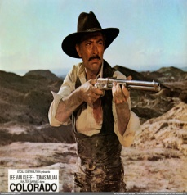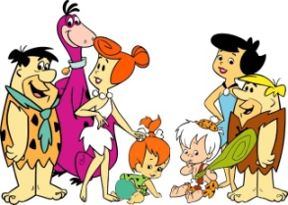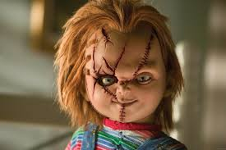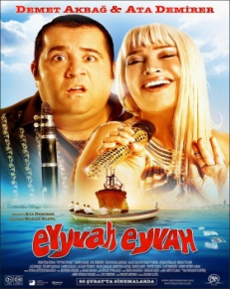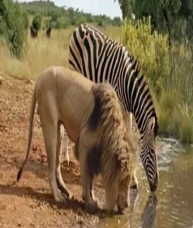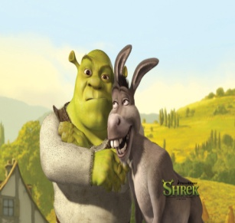

1........................ 2................... 3......................... 4..........................5.......................... 6........................

**4.BÖLÜM Aşağıdaki kelimeleri resimlerle eşleştiriniz(Match the words with the pictures)(4X2=8points)**

**A-balloons B-cake C-present D-candle**

   

**…….… ……..… ….…….. …….…**

**5.BÖLÜMMark the sentences True (T) or False (F). (2x5= 10 puan)**

1) A: Ahmet has a headache. B: He should take an aspirin. T F

2) A: I have got a sore throat. B: You should drink cold water. T F

3) A: I have a fever. B: You should go to school. T F

4) A: I have a backache. B:You shouldn’t carry heavy things. T F

5) A: Elif has got a flu. B: She should use a tissue. T F

**6.BÖLÜM Look at the poster and answer the questions.**

**( Film posterine bakınız ve soruları cevaplayınız) (3x4:12pts)**

 ICE AGE

1. **Director: Chris Wedge**
2. **Starrings:Ray Ramano,Dennis Leary**
3. **Genre: Animation**
4. **Time: 15.30 Ticket: 15tl**

1) How much is the ticket? ................................................................................................

2) Who is the director? ..................................................................................................

3) Who are starrings? ...................................................................................................

*7.BÖLÜM Read the invitation card and fill in the blanks (5*2=10 points)*

|  |
| --- |
| **On** |
| **in** |
| **dear** |
| **birthday** |
| **at** |

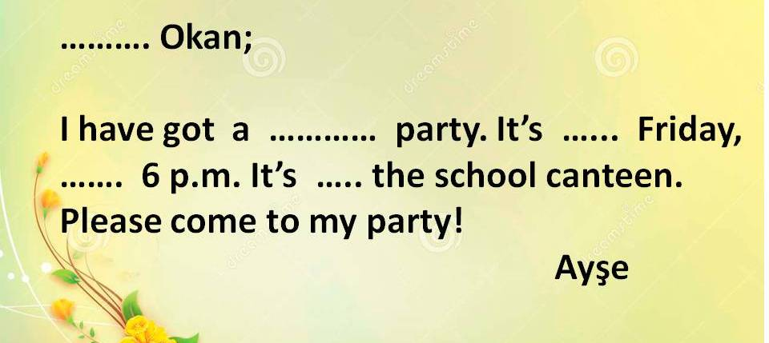

**8 BÖLÜM Aşağıdaki hastalıkları resimleri ile eşleştiriniz.(6x2=12 puan) SADECE EN İYİ BİLDİĞİNİZ 6 TANESİNİ EŞLEŞTİRELİM LÜTFEN.**

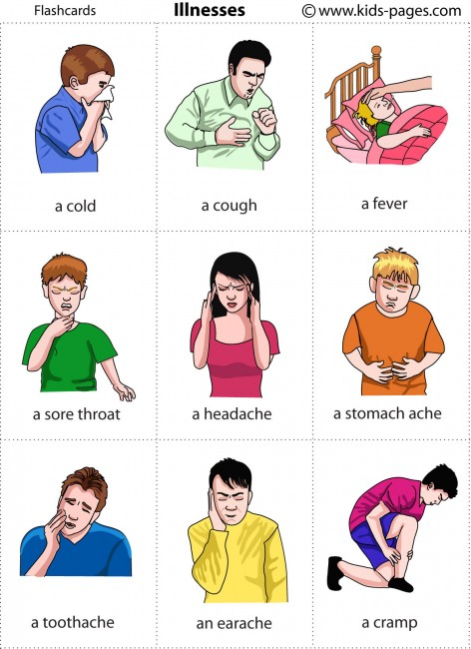********

**1**-A headache

**2**-A sore throat

**3**-An earache

**4**-A cough

**5**-The flu

**6**-A stomachache

**7**-A toothache

**8-**A fever



**9. BÖLÜM Write the types of the movies under the pictures.**

(Resimlerin altına film türlerini yazınız) (3x2:6 pts)

**A- science fiction B- horror C- animation D- western E- comedy**

1)In...............................movies,there are ghosts,vampires and strange creatures

2)In...........................films,there are cowboys and horses.

3)In ..................................films,we have fun and laugh a lot.

**- science fiction**

**- horror**

**- animation**

**- western**

**- comedy**

**10. BÖLÜM Aşağıdaki cümleler tabloya göre doğruysa TRUE yanlışsa FALSE kutusunu işaretleyin. 5x2= 10**

|  |  |  |  |  |  |
| --- | --- | --- | --- | --- | --- |
|  | **Cartoon** | **Horror** | **Cookery programme** | **Documentary** | **Sience- fiction** |
| **ILKER** | sad smiley | http://designsinmylocket.files.wordpress.com/2012/12/smiley-face.jpg?w=1200 | http://designsinmylocket.files.wordpress.com/2012/12/smiley-face.jpg?w=1200 | sad smiley | http://designsinmylocket.files.wordpress.com/2012/12/smiley-face.jpg?w=1200 |
| **MUCAHIT** | http://designsinmylocket.files.wordpress.com/2012/12/smiley-face.jpg?w=1200 | sad smiley | sad smiley | http://designsinmylocket.files.wordpress.com/2012/12/smiley-face.jpg?w=1200 | sad smiley |
| **PINAR** | sad smiley | sad smiley | http://designsinmylocket.files.wordpress.com/2012/12/smiley-face.jpg?w=1200 | sad smiley | http://designsinmylocket.files.wordpress.com/2012/12/smiley-face.jpg?w=1200 |
| **ESRA NUR** | sad smiley | http://designsinmylocket.files.wordpress.com/2012/12/smiley-face.jpg?w=1200 | sad smiley | http://designsinmylocket.files.wordpress.com/2012/12/smiley-face.jpg?w=1200 | sad smiley |

**04.04.2017**

**AYDIN DEMİRAL**

**OKUL MÜDÜRÜ**

GOOD LUCK

MEHMET DEĞERLİ

ENGLISH TEACHER

|  |  |  |  |
| --- | --- | --- | --- |
|  |  | TRUE | FALSE |
| 1 | Ilker likes watching cartoon. |  |  |
| 2 | Mucahit loves watching documentary. |  |  |
| 3 | Pınar hates documentary. |  |  |
| 4 | Esra Nur and Mucahit hates science- fiction |  |  |
| 5 | Ilker hates watching horror. |  |  |

**2016/2017 ACADEMIC YEAR DADAY ANADOLU IMAM HATIP SECONDARY SCHOOL**

**SECOND TERM FIRST WRITTEN EXAM FOR THE FIFTH CLASSES**

**CEVAP ANAHTARI**

**1.BÖLÜM Complete the sentences with “CAN” “CAN’T”. (10 points)**

|  |  |  |  |  |
| --- | --- | --- | --- | --- |
|  | RIDE A BCYCLE | SWIM | READ ABOOK | PLAY TENNIR |
| AYŞE | sad smiley | http://designsinmylocket.files.wordpress.com/2012/12/smiley-face.jpg?w=1200 | http://designsinmylocket.files.wordpress.com/2012/12/smiley-face.jpg?w=1200 | sad smiley |
| DENİZ | http://designsinmylocket.files.wordpress.com/2012/12/smiley-face.jpg?w=1200 | sad smiley | http://designsinmylocket.files.wordpress.com/2012/12/smiley-face.jpg?w=1200 | sad smiley |
| BURAK | sad smiley | http://designsinmylocket.files.wordpress.com/2012/12/smiley-face.jpg?w=1200 | sad smiley | http://designsinmylocket.files.wordpress.com/2012/12/smiley-face.jpg?w=1200 |

**1.** Burak..........can’t..................... ride a bicycle. **4.** Ayşe ............can................... swim.

**2.** Ayşe and Deniz......can’t.................... play tennis. **5.** Deniz...........can.................... read a book.

**3.** Burak .........can...................... swim.

**2.BÖLÜM Circle the correct one. (3x4=12p)**

1. l don’t like horror films because they’re …. pleasant / **scary**

2. I like comedy films beacuse they ‘re…. **Funny** / boring

3. I love detective films. They are usually … **exciting**  / funny.

***3.BÖLÜM* WRITE THE NAMES OF THE FILMS UNDER THE PICTURES**

(Resimlerin altına film türlerini yazınız) (5x2=10p)

|  |
| --- |
| **A= documentary B=horror C=romantic D=western E= musical**  **F=cartoon G=science fiction H=dedective I=animation J=comedy** |



1.............D........... 2.......F........... 3..........B.............. 4.........J..............5........A.................6.........I..............

**4.BÖLÜM Aşağıdaki kelimeleri resimlerle eşleştiriniz(Match the words with the pictures)(4X2=8points)**

**A-balloons B-cake C-present D-candle**

   

**…B….… …A…..… ….D….. …C.…**

**5.BÖLÜMMark the sentences True (T) or False (F). (2x5= 10 puan)**

1) A: Ahmet has a headache. B: He should take an aspirin.  **T** F

2) A: I have got a sore throat. B: You should drink cold water. T **F**

3) A: I have a fever. B: You should go to school. T  **F**

4) A: I have a backache. B:You shouldn’t carry heavy things. **T**  F

5) A: Elif has got a flu. B: She should use a tissue.  **T** F

**6.BÖLÜM Look at the poster and answer the questions.**

**( Film posterine bakınız ve soruları cevaplayınız) (3x4:12pts)**

 ICE AGE

1. **Director: Chris Wedge**
2. **Starrings:Ray Ramano,Dennis Leary**
3. **Genre: Animation**
4. **Time: 15.30 Ticket: 15tl**

1) How much is the ticket? ..........15TL..........................................................................

2) Who is the director? ........... **Chris Wedge**.................................................................

3) Who are starrings? ........ **Ray Ramano,Dennis Leary**...........................................

*7.BÖLÜM Read the invitation card and fill in the blanks (5*2=10 points)*

|  |
| --- |
| **On** |
| **in** |
| **dear** |
| **birthday** |
| **at** |

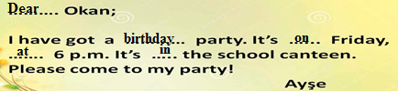

**8 BÖLÜM Aşağıdaki hastalıkları resimleri ile eşleştiriniz.(6x2=12 puan) SADECE EN İYİ BİLDİĞİNİZ 6 TANESİNİ EŞLEŞTİRELİM LÜTFEN.**

 2 4 1 3**

**1**-A headache

**2**-A sore throat

**3**-An earache

**4**-A cough

**5**-The flu

**6**-A stomachache

**7**-A toothache

**8-**A fever



**7 8 6 5**

**9. BÖLÜM Write the types of the movies under the pictures.**

(Resimlerin altına film türlerini yazınız) (3x2:6 pts)

**A- science fiction B- horror C- animation D- western E- comedy**

1)In............B...................movies,there are ghosts,vampires and strange creatures

2)In............D.............films,there are cowboys and horses.

3)In ...........E.....................films,we have fun and laugh a lot.

**- science fiction**

**- horror**

**- animation**

**- western**

**- comedy**

**10. BÖLÜM Aşağıdaki cümleler tabloya göre doğruysa TRUE yanlışsa FALSE kutusunu işaretleyin. 5x2= 10**

|  |  |  |  |  |  |
| --- | --- | --- | --- | --- | --- |
|  | **Cartoon** | **Horror** | **Cookery programme** | **Documentary** | **Sience- fiction** |
| **ILKER** | sad smiley | http://designsinmylocket.files.wordpress.com/2012/12/smiley-face.jpg?w=1200 | http://designsinmylocket.files.wordpress.com/2012/12/smiley-face.jpg?w=1200 | sad smiley | http://designsinmylocket.files.wordpress.com/2012/12/smiley-face.jpg?w=1200 |
| **MUCAHIT** | http://designsinmylocket.files.wordpress.com/2012/12/smiley-face.jpg?w=1200 | sad smiley | sad smiley | http://designsinmylocket.files.wordpress.com/2012/12/smiley-face.jpg?w=1200 | sad smiley |
| **PINAR** | sad smiley | sad smiley | http://designsinmylocket.files.wordpress.com/2012/12/smiley-face.jpg?w=1200 | sad smiley | http://designsinmylocket.files.wordpress.com/2012/12/smiley-face.jpg?w=1200 |
| **ESRA NUR** | sad smiley | http://designsinmylocket.files.wordpress.com/2012/12/smiley-face.jpg?w=1200 | sad smiley | http://designsinmylocket.files.wordpress.com/2012/12/smiley-face.jpg?w=1200 | sad smiley |

GOOD LUCK

MEHMET DEĞERLİ

ENGLISH TEACHER

|  |  |  |  |
| --- | --- | --- | --- |
|  |  | TRUE | FALSE |
| 1 | Ilker likes watching cartoon. |  | X |
| 2 | Mucahit loves watching documentary. | X |  |
| 3 | Pınar likes documentary. |  | x |
| 4 | Esra Nur and Mucahit hates science- fiction | X |  |
| 5 | Ilker hates watching horror. | X |  |

**04.04.2017**

**AYDIN DEMİRAL**

**OKUL MÜDÜRÜ**