Tarih:….. /…... /

Adı : Soyadı : No :
Aldığı Not :

…………………………SECONDARY SCHOOL
2021-2022 EDUCATIONAL YEAR
6TH GRADERS’ 2ndTERM 1st WRITTEN EXAM
- Match the phrases in the box with the pictures. (14 p)
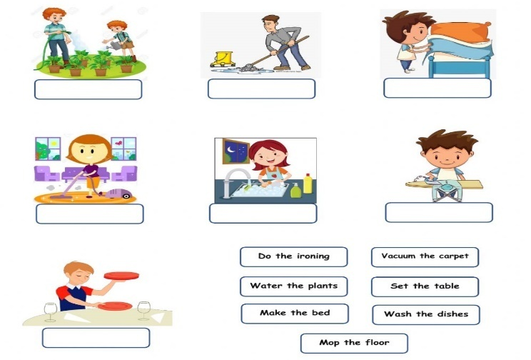  g  a  f  e  d  c  b | - Do the ironing …………  - Vacuum the carpet…………  - Make the bed………….  - Water the plants……………  - Set the table…………….  - Wash the dishes…………  - Mop the floor………………

- Complete the sentences with the ‘have to, has to, don’t have to, doesn’t have to) ( 14 p)
- Dad can’t take us to the sports center today .We…………………...........take the bus .

- Students ………………………….pay.Tthe museum is free for them.

- She…………………………….clear the table.That’s her brother’s jop!

- Poor Mom; she………………………..work on Sundays.

- It’s dinner time ! you……………………set the table .

- We’re going out for a meal. We………………………..do the dishes!

- They can’t go out tonight. They ………………………………..study for a test.

- Complete the story with the words in the box.(18 p)
anyone, no one, something, nothing, someone, nobody, anything, something, anyone

It was Saturday afternoon. I was home. There was ……………….in the house with me. I had …………………….to do. Therewasn’t……………………….good on TV. I was bored and I was hungry. Then I heard……………………..upstairs. ‘oh no!’ I thought, ‘there’s……………………….in the house!’ I went upstairs. ‘Is there…………………there?’I asked, but…………………..answered. I openedthe door slowly. The window was open, but there wasn’t………………….there. Then…………………black and white ran out of the door and down the stairs. It was coco;mrs. Jenson’s cat!

- Match the words with the forms of transportation in the pictures.(24 p)
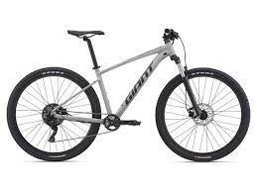a | 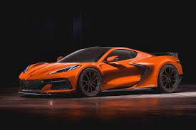b | 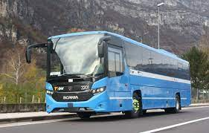c |  | d |  | 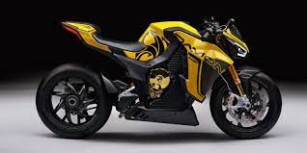e |  | f
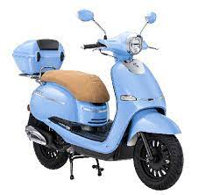g | 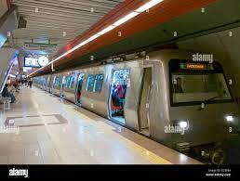h |  | 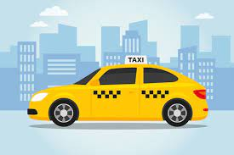ı |  | 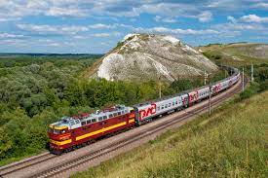j |  | 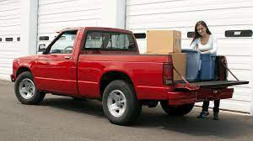k |  | 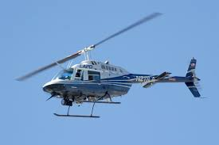m
1.Car………. 2. Bus……….. . 3. Bicycle………. . 4. Ferry………. . 5. Motorcycle……. . 6. Plane……
7. scooter……. . 8. Subway….. . 9. Taxi…… . 10. Train…… . 11. Pickup truck……. . 12. Helicopter…

- Look at the signs and complate the sentences with ‘ must, mustn’t’ ( 15 p)
You_________take photographs. | 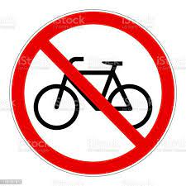  You_________ride bikes here. | You__________go straight. | 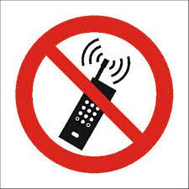  You_________use your phone. | You_________stop here.

Can, sorry, can’t, of course, but
- Complate the dialogue with the words in the box. ( 15 p)

Jo: May I go bowling with Robin, Mom?
Mom: No, I’m ____________, you ____________. You have school tomorrow.
Jo: ____________I watch TV, then?
Mom: Yes, ________________, ______________don’t stay up late.

GOOD LUCK

