ACADEMIC YEAR……. SECONDARY SCHOOL 2ND Term 1st EXAM FOR 6TH GRADERS
NAME: SURNAME: CLASS:
A)Write the correct words under the pictures.(2*5=10 p)
Carousel - bumper car - ghost train - ferris Wheel - roller coaster
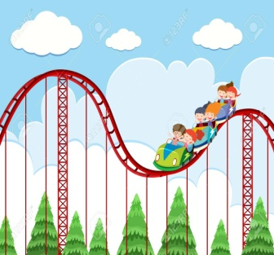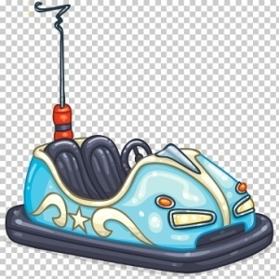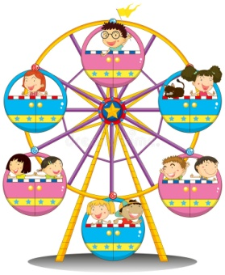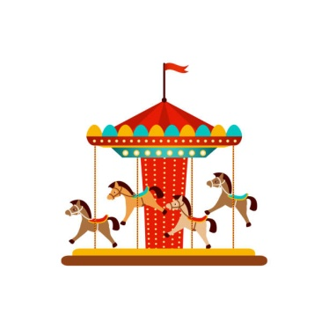
_______________ ___________________ ________________ _________________ ________________
B)Circle the correct options.(3*4=12 p)
1.A:I think carousel is boring.
B:I agree / disagree.They are dull. I don’t like them.
2.A:What do you think about roller coaster?
B:I think they are boring/fantastic.I love them.

4.A:What do you think about carousel and ferris Wheel?
B:I think ferris Wheel is better / gooder than carousel.
3.A:Fairs are fabulous.I like them.
B:I agree / disagree.I hate fairs.They are very crowded and noisy.

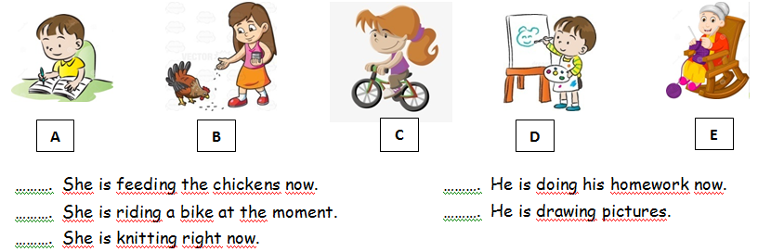
C))Match the sentences with the pictures.(3*2=6 p)
D.Cümleleri tablodaki mesleklerle doldurunuz. (10 Pts)
vet pilot tailor mechanic engineer nurse teacher hairdresser saleswomanwaiter

- Jack is a ………………… He repairs cars.
- Jim is a ……………………… He likes teaching new things at school.
- Sue is a …………………………… She helps sick people. She works at a hospital.
- James is an …………………………He builds houses.
- Shelia is a ……………………She makes clothes and sew dresses.
- Serhat is a …………………He serves food and drinks at a restaurant.
- I am a …………………..I can fly planes.
- Suzan is a ………………… She cuts, combs and designs hair.
- Vefa can examine animals. He is a ........................................
- Burcu is a ............................................ she sells goods at a shop.

D. Altı çizili fillerden doğru olanı yuvarlak içine alınız.(10 Pts)

- We walk/ walked in the forest last Saturday. 6)Did you visit/ visited your Aunt?
- The weather is sunny today/ yesterday. 7)Yes I did/ didn't.
- I didn't learn /learned skiing last year. 8)I try/ tried sailing in 2008
- My sister is 5 years old now/ last year. 9)I didn't try/ tried paragliding but I try/ tried climbing a mountain
5)We watch/ watched a documentary two days ago. 10)I stay/ stayed in a tent last week

E)Metne göre cümlelerin doğru (T) mu yanlış (F) mı olduklarını belirtiniz.(4x2:8Pts)

Hello, I am Peter and this is my family. Last summer, we went to İzmir. My family and I stayed in a tent. My sister and I went swimming in the mornings. We played games, climbed mountains and picked flowers. My mother cooked in the evenings. My father went hiking. We sang songs and danced. It was a fantastic holiday. We had a great time.
1) They went to İzmir last summer. TRUE / FALSE,
2) They stayed at a comfortable hotel. TRUE / FALSE
3) They didn’t play games. TRUE / FALSE
4) His father went hiking. TRUE / FALSE
F. Soruları tabloya bakarak cevaplayınız. (10 Pts)
 | Occupation | Date of Birth | Place of Birth
M.Kemal Atatürk | President | 1881 | Salonika
Sabiha Gökçen | Pilot | 1913 | Bursa
Barış Manço | Singer | 1943 | İstanbul
- When was Atatürk born?................................................................................................................
- What was Sabiha Gökçen's occupation?.......................................................................................
- Where was Barış Manço born?......................................................................................................
- When was Sabiha Gökçen born?....................................................................................................
- What was Barış Manço's occupation?..........................................................................................
G) Fill in the blanks with “was”“were”and am,is ,are . (1X12=12)
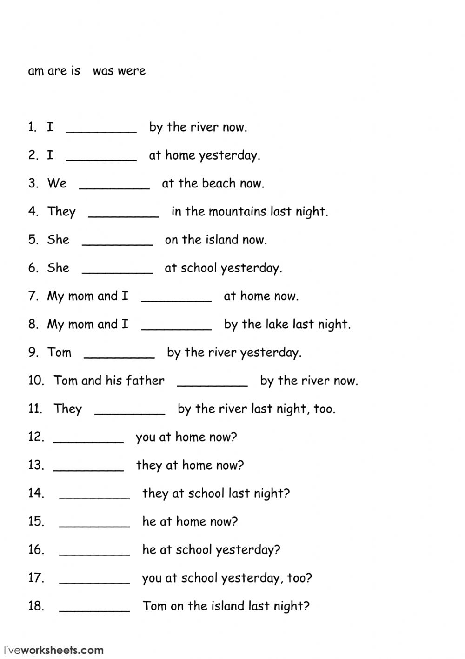
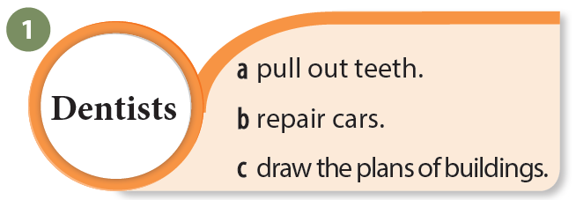
H) Verilen mesleklerdeki kişiler ne yaparlar? Doğru seçeneği işaretleyiniz (6x2=12 Pts)
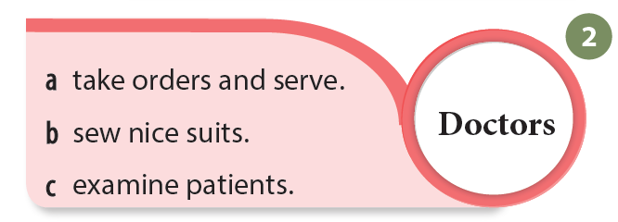

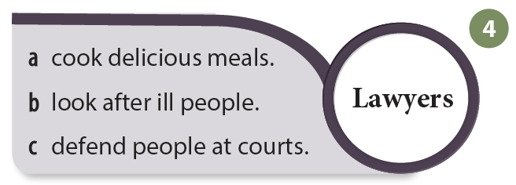
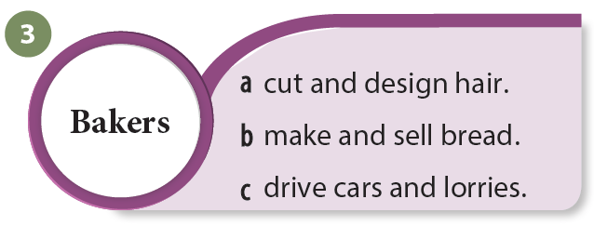

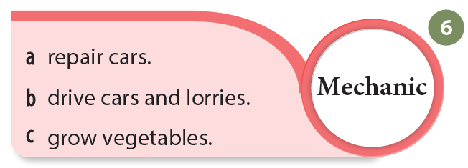
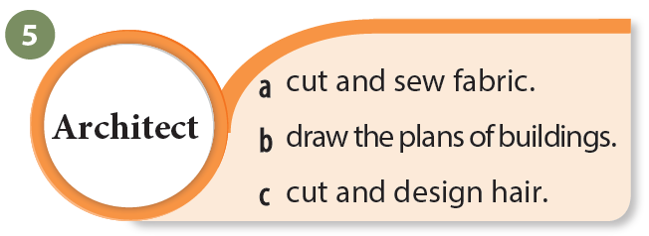

I. Verilen filleri uygun resmin altına yazınız (5x2=10 pts)
walk in the forest swim learn skiing watch TV pick up fruits

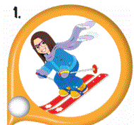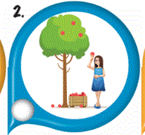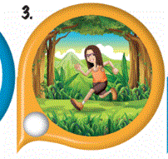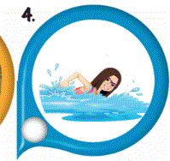

........................... ........................... ......................... ...................... .......................
E.Verilen tarihlerin okunuşlarını örnektekine bakarak yazınız. (10 Pts)
e.g.3 March 1987: The third of March, nineteen eighty seven.
1) 7 July, 1984: _____________________________________________________________________
2) 21 January, 2008: _____________________________________________________________________
3) 13 May, 1864: _____________________________________________________________________
4) 20 February, 2019: _____________________________________________________________________
5) 28 August 1583: _____________________________________________________________________

