- A giraffe is ………………. than a horse
- shorter B) taller C) sadder D) colder

- Selma : ………………
Zeynep : I feel happy and energetic because it is
sunny and warm today.

- How do you feel today?
- What do you have for breakfast?
- Do you feel anxious?
- What’s the weather like?

- Verilen resme en uygun olan cümleyi seçiniz.
…………………

A) It is hot and sunny.
B) It is warm here today.
C) It is freezing cold.
D) It is rainy and wet.

- Selma : ………………
Zeynep : it is cold and snowy today.

- What’s the weather like?
- How do you feel today?
- What do you have for breakfast?
- Do you feel anxious?
- Verilen resme en uygun olan cümleyi seçiniz.
I feel ……….. because it is stormy. Korkmuş biri

- happy
- scared
- cold
- tall

- Antony: …………………………..
Bertha : Bread, eggs, olives and cheese.

- What time do you get up?
- How is the weather?
- What do you have for breakfast?
- Where do you go?

- Verilen bilgilere gore doğru olan cümleyi seçin.

Pelin is 6 years old.

Miray is 4 years old

- Mirayis older than Pelin.
- Pelin is more beautiful than Miray.
- Pelin is older than Miray.
- Miray is faster than Pelin.
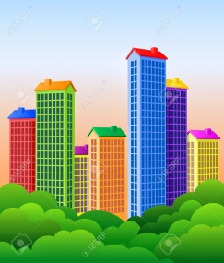
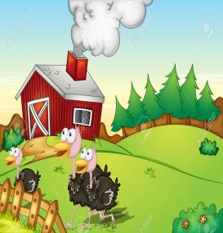
8. Aşağıda görsellerle ilgili verilen bilgilerden hangisi yanlıştır?

A) The country is quieter than the city.
B) The city is dirtier than the village.
C) The country is more crowded than the city.
D) The country is more relaxing than the city.
9. Aşağıdaki hava olaylarının doğru sıralanışı
hangi seçenekte verilmiştir.

A) sunny / windy / rainy B) rainy / windy / sunny
C) windy / sunny / rainy D) sunny / rainy / windy
10. Altı çizili saati gösteren resmi seçin.

A: What time is it?
B: It’s seven o’clock.
A) B)

C) D)

11. Selma: ………………
Zeynep : It’s twenty degree Celcius.

- What’s the weather like?
- How do you feel today?
- What do you have for breakfast?
- What’s the temperature?
12. There aren’t …….. watermelons in the picture.

- any B) some C) a little D) much
13. My mother is in the kitchen.
She is ………..

A) feeding the dog.
B) reading a book.
C) cooking.
D) watching TV.

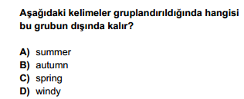

14.

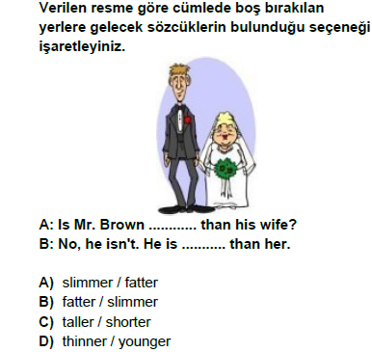
15.

htps://www.HangiSoru.com
16. What are they doing?

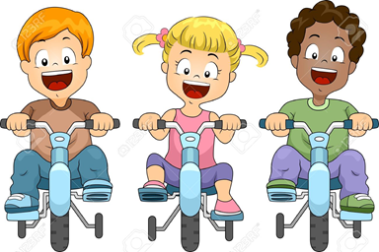
A) They are waiting for the bus.
B) They are taking a nap.
C) They are cycling.
D) They are having a snack.

17.Arnold is ………than Kevin.
.
A) shorter
B) fatter
C) thinner
D) smaller Arnold Kevin

18. Ali : Would you like to eat bagel?
Defne : ................., I don’t like it.

A) Yes,yummy B) No,thanks
C) Yes,please D) I like

19. There are a lot of cars in the street and they can’t move at all because there is a ………

A)traffic jam
B) downtown
C)skyscraper
D) traffic light

20. I feel upset on rainy days and I want
to…………………..

A) sing songs
B)sleep all day
C) dance with my friends
D) make a party

https://www.HangiSoru.com

