NAME SURNAME: …………………………………………………… NO: …………… GRADE:6/B
- WRITE COMPARATIVE SENTENCES (25P)
0. 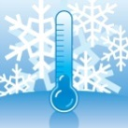Erzurum is colder than Antalya. 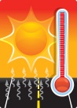(cold)
00. 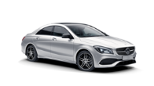Mercedes is more expensive than Broadway. 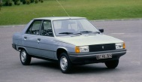 (expensive)
1. Hayri IS FATTER THAN Kamil. 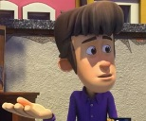 (fat)
2. 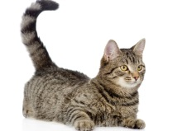A cat IS SMALLER THAN a horse. 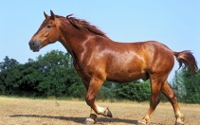 (small)
3. 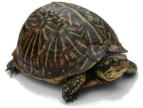 A turtle IS SLOWER THAN a rabbit. 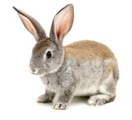 (slow)
4. 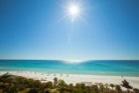 Manisa IS SUNNIER THAN Trabzon. (sunny)
5. 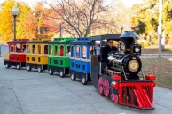 Train ride IS MORE BORING THAN roller coaster. 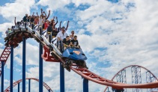 (boring)

- WRITE WHAT HE IS DOING NOW (25P)
 | 0. He is playing football now. |  | 1. HE IS PLAYING COMPUTER GAMES NOW.
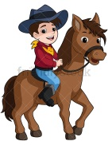 | 2. HE IS RIDING A HORSE NOW. |  | 3. HE IS PLAYING BASKETBALL NOW.
 | 4. HE IS COOKING NOW. | 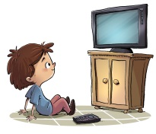 | 5. HE IS WATCHING TV NOW.

- ANSWER THE QUESTIONS ACCORDING TO THE TABLE GIVEN BELOW (30P)
Tekirdağ | Anakara | Kars
18 °C | 12 °C | -5 °C
 | 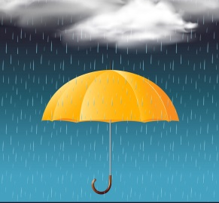 | 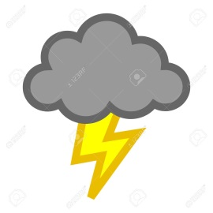

- What is the temperature in Tekirdağ? - It’s eighteen degrees Celsius.
- How is the weather in Tekirdağ? - It’s cloudy.
- How do you feel in Tekirdağ? - I feel moody.

- What is the temperature in Ankara? - IT’S TWELVE DEGREES CELSIUS.
- How is the weather in Ankara? - IT’S RAINY.
- How do you feel in Ankara? - I FEEL SLEEPY.
- What is the temperature in Kars? - IT’S MINUS FIVE DEGREES CELSIUS.
- How is the weather in Kars? - IT’S LIGHTNING.
- How do you feel in Kars? - I FEEL SCARED.
- WRITE THE GIVEN PHRASES UNDER THE CORRECT PICTURE (20P)
Roller coaster | Bumper car | Ferris wheel | Carousel

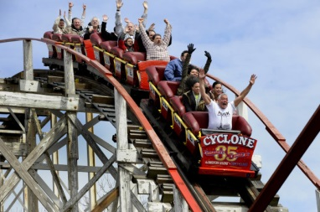 | 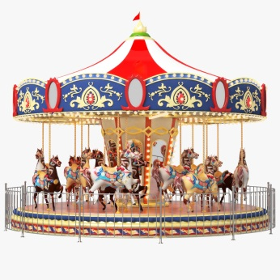 | 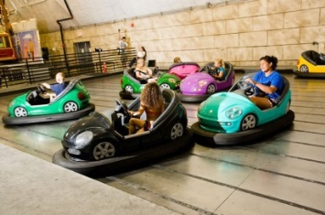 | 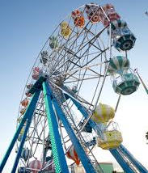
ROLLER COASTER | CAROUSEL | BUMPER CAR | FERRIS WHEEL

Baki ÖZEN
İngilizce Öğretmeni

