EDUCATION YEAR ………………….…… SECONDARY SCHOOL

**7th GRADES 1st TERM 2nd ENGLISHWRITTEN EXAM**

**Name- Surname: Number: Class: 7/ Mark:**

1.**Fred: I have a new classmate. His name is Robb.**

**Ken: - - - - ?**

**Fred: He is tall and slim with short curly hair.**

a) What does he look like? b) Is he helpful? c) Who has ginger hair? d) What’s he like?

**Graham Bell was the inventor of the telephone. He was born in 1847 in Scotland. He moved to USA and worked for deaf people at Boston University. He worked on telephone with Thomas Watsone. He died in 1922 in Canada.**

2.

**Yukarıdaki parçada aşağıdakilerden hangisinin cevabı yoktur?**

a) Where and when was G.Bell born? b) What did Graham Bell work for?

c) What did Graham Bell invent? d) Did Graham Bell get married?

3**. “19 May 1919” tarihinin okunuşu hangi şıkta doğru verilmiştir?**

a) Nineteen May nineteen nineteen b) May the nineteenth,nineteen ninety

c) Nineteenth of May ninety-nine d) May the nineteenth ,nineteen nineteen

4. **Alice: ……………………………………………..? Jack: About fifteen years.**

a)How long do piranhas live? b)What is the class of piranhas?

c)What do piranhas eat? d)Where do piranhas live?

**5. Alice: What should we do for endangered animals? Jack: Sure. …………………**

a)We should hunt them.They are very delicious. b)We should wear fur by killing them.

c)We cut destroy forest. d)We donate money to the zoo to help them.

6.**Which one is TRUE?**

A) We should protect the endangered animals. B) We should overkill the animals.

C) We shouldn’t protect forests. D) We should overhunt the animals.

7.**Last night, I watched a ………. about wild animals.I like watching that TV programme,because it is educational.**

**a)cartoon b) news c) series d) documentary**

https://www.HangiSoru.com

8-**The Great Leader Atatürk ………. at the age of 57 at Dolmabahçe Palace on 10th November, 1938.**

**a)graduated b)was born c)became d)died**

9.**Last week, we watched a football match with my dad. The final score was BJK=2 TS=2.There were four goals but it was a ………..**

**a)beat b) draw c) defeat d)win**

10.**What does a panda look like?**

a)It has got a black and white fur.b)It is a herbivore.

c)It lives in bamboo forests.d)It is endangered.

11.**They are big animals. They have big ears. They have a trunk and two tusks. They have got a small tail. They are …….**

**a)seals b) zebras c) tigers d) elephants**

12.**Aşağıdaki metinde anlam bütünlüğünü bozan cümle hangisidir?**

**I.My best friend, Sude is a beautiful girl. II. She’s tall and slim. III. She prefers watching documentary. IV.She has blonde hair and blue eyes.**

A) I B) II C) III D) IV

13.**Esma: ……… was Aziz Sancar born?Nazlı: In Savur, Mardin**

a)When b) Where c) Why d) Who

**[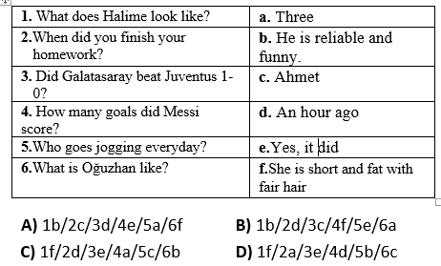](https://www.HangiSoru.com/)**14.

15. **Alex:-------------------------? Robb: In 1847.**

a) Who is Edison b)When did Edison win the Nobel Prize

c) What did Edison discover d) What did Edison study

|  |  |  |  |  |
| --- | --- | --- | --- | --- |
|  | **News** | **Documentary** | **Talk Show** | **Sit-Com** |
| **Katie** | ✓ | ✓ | x | x |
| **Sophie** | x | x | ✓ | ✓ |
| **Scott** | ✓ | x | ✓ | x |
| **William** | x | ✓ | x | ✓ |

**16/17/18.soruları tabloya göre yanıtlayalım.**

16. **…. prefers talkshow to sitcom.**

a. Katie b. Sophie c. Scott d. William

17.**Scott prefers …………….… and …………….…**

a. News / documentary b. Talk Show / news c. Documentary / sit-com d. Sitcom / news

18**. …… and ……… prefer ……… Because they want to learn new things**.

a. Katie / Sophie / documentary b. Sophie / William / sitcom

c. William / Katie / documentary d. Sophie / Scott / documentary

**19. Hangi görselden bahsedilmemiştir?**

|  |
| --- |
| * We should stop deforestation * We should recycle plastics * We shouldn’t go to circus |

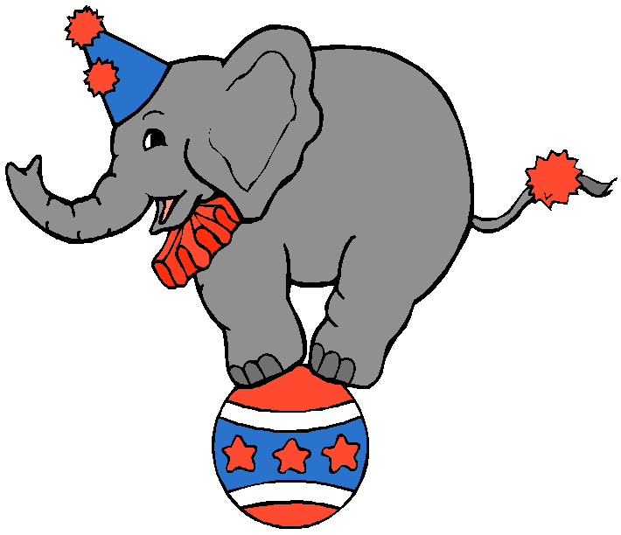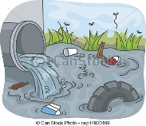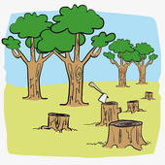a) b) c) d)

20. **Betty: - - - - ? Adam: She was a scientist.She discovered radium and polonium.**

a) Did Marie Curie get married? b) Where was Marie Curie born?

c) When did Marie Curie die ? d) Who was Marie Curie?

21.**Which one is false?Hangi eşleştirme yanlıştır?**

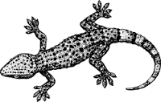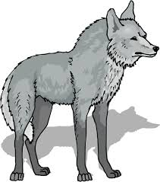 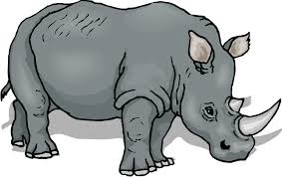

1. **lizard b)giraffe c)lion d)rhino**

**22**.**Camels live in ..........................**

A) the desertsB) the oceans C) the jungles D)savannah

|  |  |
| --- | --- |
| **STUDENT** | **INFORMATION** |
| **Hande** | A snake has got scales |
| **Emre** | An eagle has got wings |
| **Ceren** | A zebra has got a trunk |
| **Arda** | A lion has got a mane |

**23. Hangi öğrencinin verdiği bilgi yanlıştır?**

A) Ceren B) Emre C) Hande D) Arda

**24.Wilhelm Conrad Röntgen……….from the University of Zurich in 1869 and……a professor in 1875.**

A)born / became B)grow up / married C) graduated / became D)moved/ died

|  |  |
| --- | --- |
| **Herbivore** | **Carnivore** |
| **zebra** | **lion** |
| **cow** | **- - - - - -** |
| **rhino** | **tiger** |
| **- - - - - - -** | **crocodile** |

**25.Boşluklara sırasıyla aşağıdakilerden hangisi gelmelidir**?

a)cheetah - donkey b)shark –kangarooc)panda – wolf d)eagle – giraffe

https://www.HangiSoru.com

**26.What kind of TV programme is it ?**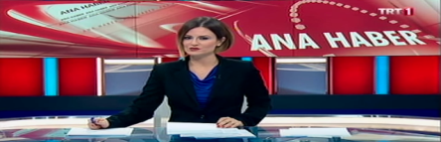

a) news b)reality show c) discussion d) cookery show

**27.Tabloya göre doğru olanı işaretleyiniz.(Which is correct according to the table?)**

|  |  |  |  |
| --- | --- | --- | --- |
|  | Scuba diving | Football | Table- tennis |
| **Halil** | ** | *** | --------- |
| **Sedef** | *** | -------- | ** |
| **Azra** | -------- | ** | *** |

**---- never ** sometimes ***often**

A)Halil often goes scuba-diving.

B)Sedef never plays table tennis.

C)Azra sometimes plays football.

D)Halil often plays table tennis.

**28. Football is ………… tennis in Turkey.**A)popular more than B) the more popular C)popular than D)more popular than

**29.I didn’t go to school ..............**A)yesterdayB)tomorrow C)at the momentD)everyday

**30. They are very talland they live in the savannahs. They have spots on their body.**

a)giraffes b)lions c)whales d)penguins

**GOOD LUCK…………………………………………………….**