**EDUCATION YEAR**

**……………. SECONDARY SCHOOL 1st TERM 2nd SELECTIVE ENGLISH EXAM FOR BEP STUDENTS**

**NAME&SURNAME: CLASS&NUMBER:**

***A) Kelimeler ve Hayvanları Eşleştiriniz. (10x4= 40p.)***

|  |  |  |  |  |
| --- | --- | --- | --- | --- |
| **Cheetah ………….** | **Lion …………** | **Crocodile …………** | **Ostrich …………** | **Turtle ………..** |
| **Tiger ………….** | **Elephant ………..** | **Bear ………..** | **Snake …………** | **Kangaroo ………….** |

**A. B. C. D. E.**

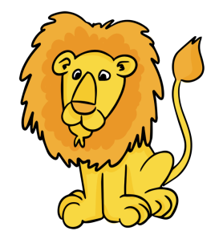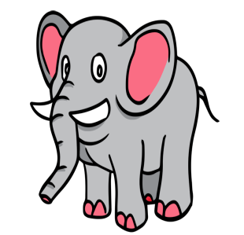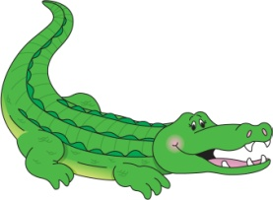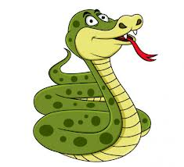

**F. G. H. I. J.**

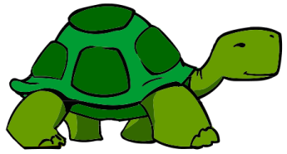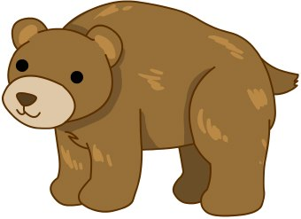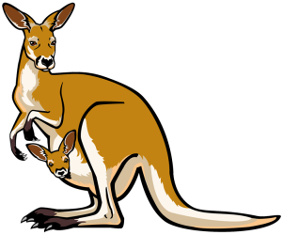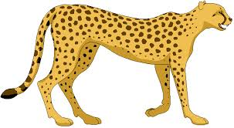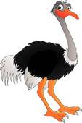

***B. Doğru Seçeneği İşaretleyiniz. (10x4= 40 p.)***

**1.**Atatürk __________ in 1881.

a. was b. was born c. born

**2.** Sheila got _____ to Bob two years ago.

a. awards b. married c. kids

**3. Kate:** I ________ up in London. Then, when I was eighteen, I moved to New York.

a. grow b. go c. have d. born

**4.** Einstein had a __________ mind.

a. brilliant b. alone c. awful d. dark

**5. Bill:** When ______ Thomas die?

**Roger:** In 2014.

a. did b. is c. does d. was

**6. Tom:** _______________ do lions live?

**Jane:** In the jungles.

a. What b. Where c. Whend. How

**7.** Humans _______________ hunt wild animals.

a. should b. canc. shouldn't d. can't

**8.** Some animals _______________ extinct because people killed them.

a. became b. becoming c. become d. becomes

**9. [](https://www.HangiSoru.com/)**Dolphins are **………..**

a. birdsb. cats c. reptiles d. mammals

**10.** Please, protect the _______________ of the animals. Let them live there in peace.

a. food b. habitats c. deserts d. preys

***C. Hayvanları Türlerine Göre Gruplayınız (9x2=18 p.)***

*[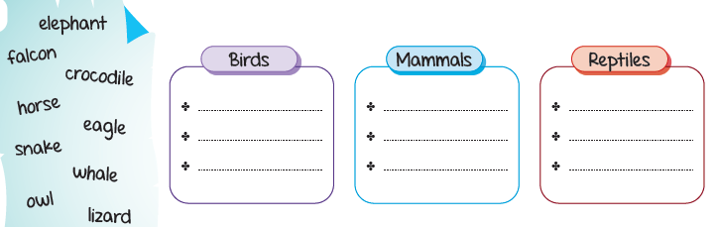](https://www.HangiSoru.com/)*

***[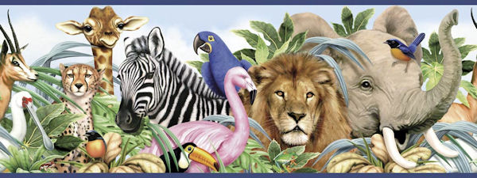](https://www.HangiSoru.com/)D.*(2 p.)**

These are ……………………………………….

a. Wild animals

b. Pets

c. Herbivores

d. Plants

………

English Language Teacher