SCHOOL FIRST TERM SECOND ENGLISH EXAM
READİNG(3X4=12)
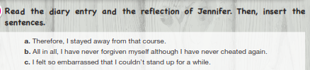
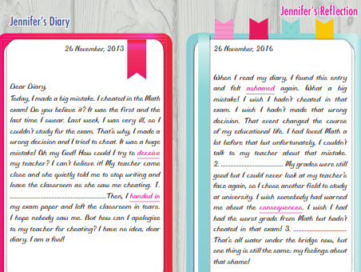

VOCABULARY(4X5=20)
CHOSE THE CORRECT OPTİONS
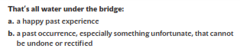
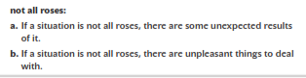
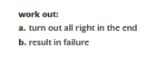
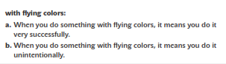

GRAMMAR(5X6=30)
CHOOSE THE CORRECT ANSVERS.
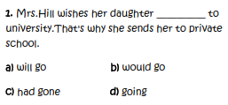
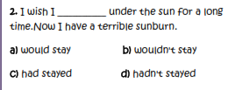
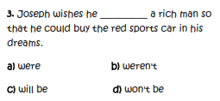
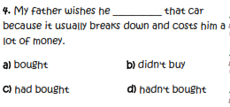
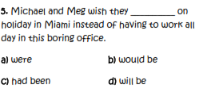
WRİTİNG.(10X2=20)
WRİTE DOWN AN APROPRİATE CV FOR THE JOB THAT YOU WANT TO HAVE İN YOUR UTURE CAREER
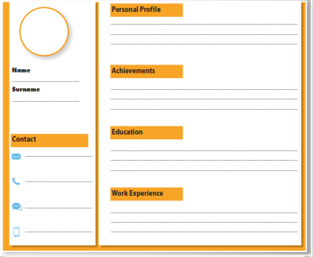
LİSTENİNG.(9X2=18)
LİSTEN TO THE TELEPHONE CONVERSATİON BETWEEN A HUMAN RESOURCES AND A JOB CANDİDATE AND COMPLETE THE DİALOGUE.
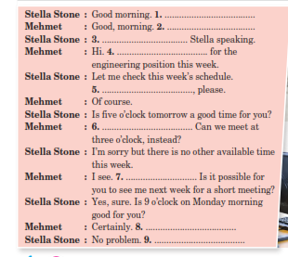

https://www.HangiSoru.com

GOOD LUCK

