ACADEMIC YEAR
PRIMARY SCHOOL 1st TERM 2nd EXAM FOR 4th GRADES

NAME : ………………………………………. CLASS :4/……….
SURNAME : ………………………………………. NUMBER : ……………………

Doğru seçeneği işaretleyiniz.

1)

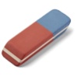
- School bag
- Eraser
- Desk
- Book

2)
- Book
- Pencil
- Sharpener
- Ruler

3)
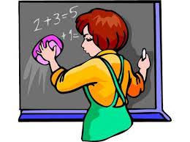
- Sit down
- Be quiet
- Clean the board
- Open your books

4)

- England
- Japan
- Germany
- Turkey

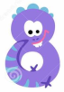
5)

- Eleven
- Ten
- Eight
- Two

6)
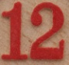

- forty two
- fifty seven
- forty eight
- sixty three

7)
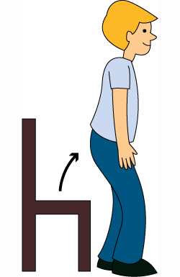
- Be quiet
- Turn on the light
- Turn around
- Stand up

8) -………. you like dancing?

- Can
- Do
- Is
- Are

9) - Do you like singing?
- Yes………….

- I do
- I can
- I am
- I don’t

10)
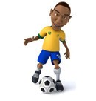

- I like playing the guitar
- I like dancing
- I like watching cartoons
- I like playing football

11)

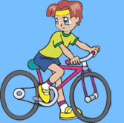

- I like playing chess
- I like reading book
- I like flying kite
- I like riding bike

12)
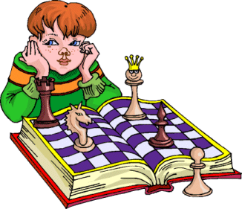
- I don’t like playing chess
- I can’t like playing with marbles
- I don’t like playing basketball
- I don’t like playing guitar

13)

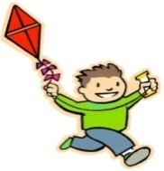
I like ……………… kite.

- Listening
- Writing
- Flying
- Learning

1-B 2-B 3-C 4-D 5-C 6-A 7-D 8-B 9-A 10-D 11-D 12-A 13-C 14-C 15-C 16-D

14) - ………… you play guitar ?
- Yes I can.

- Do C) Can
- Is D) Are

15) - Can you drive?
- No,…………..

- I am not
- I don’t
- I can’t
- I may not

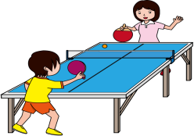
16)

- I can play basketball.
- I can swim.
- I can climb tree.
- I can play table tennis.

www.derskitabicevaplarim.com

Good Luck

