EĞİTİM ÖĞRETİM YILI
7. SINIF İNGİLİZCE 2. DÖNEM 2. YAZILI SINAVI

Name: Class: Mark:
Surname: Number:

- Fill in theblankswiththegivenwords. ( 2x5=10 pts)
save plant have dry rcycle

1. Wemust...............................paperandplastictoprotectourenvironment.
2. Wemust stop cuttingdownforeststo......................the habitat of manyanimals.
3. Wemust...........................treestomaketheworld a betterandcleanerplace.
4. Wemustn’tpollutethe planet to..............................cleanair.
5. Whentemperaturesincrease, lakesandrivers................................up.

B. Fill in theblankswiththegivenwords. ( 4x5=20 pts)

- Responsible
- Threatens
- Heating
- Temperatures
- climates
Global Warming
……………………………….areincreasingbecause of airpollution. Global warming is causingmajorchanges in ourworld. ....................................arealsochanging. Animals andplantsaretryingtolivewiththesechanges. Wemust stop thespeed of ....................................because it ....................................many of thespecies. Ifwedon’t do anything, theywill be endangered, orevenextinct. Weareall....................................forour planet!!!

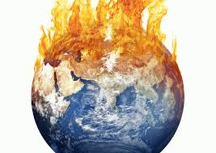

C. Türkçe anlamlarını yazınız( 4x5=20 pts)

Proof:
Observe:
Universe:
Orbit:
Surface:

D. Answerthequestionsusingtheprompts in thebox.( 4x5=20 pts)

● togetplaneticketsforholiday. ● tosee a doctor.
● toborrowsomebooks. ● toseethedolphins.
● toseetheacrobats.

1. Why do yougotohospital? ................................................................................
2. Why do yougotothelibrary? ............................................................................
3. Why do yougototheaquarium? ......................................................................
4. Why do yougotothecircus? ...........................................................................
5. Why do yougotothetravelagency? ..............................................................

E. Fill in theblankswiththegivenwords( 5x2=10 pts)
● florist’s ● butcher ●chemistry● greengrocer● bookshop

1. You can buy books at the...................................................
2. You can buy fruit at the...................................................
3. You can buy medicine at the...................................................
4. You can buy meat at the...................................................
5. You can buy flowers at the...................................................

F. TranslateintoTurkish. Türkçeye çeviriniz. (5x4=20 pts)

- The Moon is thesatellite of the Earth.
- An astronautexploresthespace.
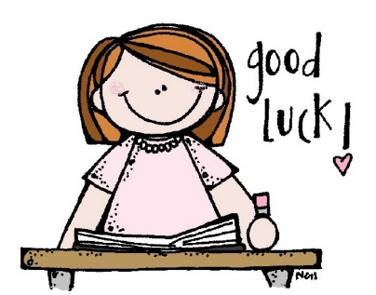
- Mercury is theclosest planet totheSun.
- Jupiter is thebiggest planet in the solar system.
- Venus is hotter than Mercury.

