[**………… PRIMARY SCHOOL 2ND TERM 2ND ENGLISH EXAM FOR 4th GRADES**](https://www.HangiSoru.com/)

Name / Surname: \_\_\_\_\_\_\_\_\_\_\_\_\_\_\_\_\_ Class: 4/ \_\_\_\_\_\_ Number: \_\_\_\_\_\_

**A) Resimleri ve kelimeleri eşleştirin.10x2=20P**

**A.NurseB.policewomanC.pilot D.vet E.chefF.dancer G.teacher H.singerI.fireman J.farmer**

  [](https://www.hangisoru.com)

1)……………………… 2)…………………………… 3)…………………………… 4)………………………… 5)…………………… [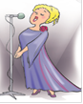](https://www.hangisoru.com) 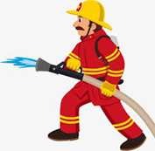

6)……………………. 7)………………………… 8)……………………………..9)…………………………. 10)……………………

**B)Aşağıda resimleri verilen mevsimleri tablodan yararlanarak yazınız.(4x4=16p)**

SUMMER SPRING WINTER AUTUMN/FALL (AUTUMN)

[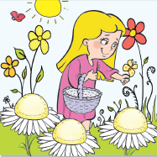](https://www.HangiSoru.com/)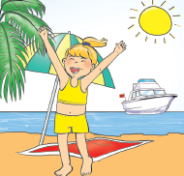[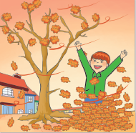](https://www.hangisoru.com)

\_\_\_\_\_\_\_\_\_\_\_\_\_\_\_\_\_\_ \_\_\_\_\_\_\_\_\_\_\_\_\_\_\_\_\_ \_\_\_\_\_\_\_\_\_\_\_\_\_\_\_\_\_ \_\_\_\_\_\_\_\_\_\_\_\_\_\_\_\_

**C)Kutucuğa bakarak resimlerin altına hava durumlarının adlarını yazınız (5x2=10 p)**

|  |
| --- |
| * **Sunny \* Windy \* Rainy \* Snowy \* Cloudy** |

|  |  |  |  |  |
| --- | --- | --- | --- | --- |
| [wow-talk-about-howling-wind-last-night-even-though-hurricane-sandy-ddbl9B-clipart](https://www.HangiSoru.com/) | snowing-clip-art-snowy-clipart-298_273 | [sunny-clipart-best-81olml-clipart](https://www.HangiSoru.com/) | sad-rain-cloud-clip-art-free-rainy-clipart-2000_2000 | clip-art-of-overcast-day-gloomy-dark-cloud-mascot-cloudy-clip-art-1300_743 |
| ………………………. | …………………….. | ………………………. | ……………………… | …………………………… |

**D. Verilen kelimeleri resimlerin altına yazınız.6X2=12P**

|  |  |  |  |  |  |
| --- | --- | --- | --- | --- | --- |
| **IN** | **ON** | **UNDER** | **BEHIND** | **IN FRONT OF** | **NEAR** |

**[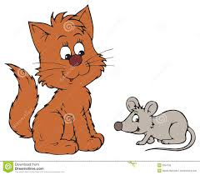](https://www.hangisoru.com)[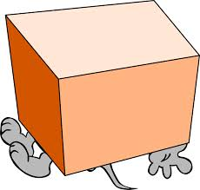](https://www.HangiSoru.com/)[](https://www.HangiSoru.com/)**

**............... ..................... ...................... ................. .................... ...................**

[https://www.HangiSoru.com](https://www.HangiSoru.com/)

**E) Resimlerle kelimeleri eşleştiriniz.(6x3=18 points)**

|  |
| --- |
| **A)** skirt**B)** umbrella **C)** sunglasses **D)** hat**E)**dress**F)** t-shirt |

**[](https://www.hangisoru.com)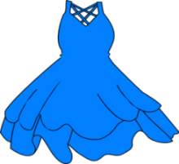**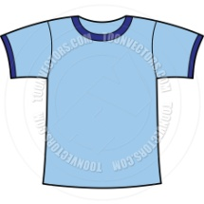**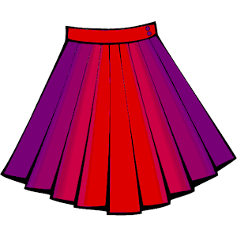**

**1...…… 2……… 3……… 4………. 5….…. 6 ……..**

**[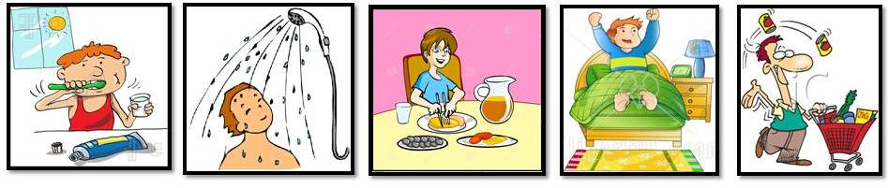](https://www.hangisoru.com)F.Resimlerin altına günlük aktiviteleri yazınız. (2x5=10 p)**

|  |  |  |  |  |
| --- | --- | --- | --- | --- |
| **A.HAVE BREAKFAST** | **B.WAKE UP** | **C.BRUSH TEETH** | **D.GO SHOPPING** | **E.HAVE SHOWER** |

\_\_\_\_\_\_\_\_\_\_\_\_ \_\_\_\_\_\_\_\_\_\_\_\_\_\_\_\_\_\_ \_\_\_\_\_\_\_\_\_\_\_\_\_\_\_\_\_\_ \_\_\_\_\_\_\_\_\_\_\_\_\_\_ \_\_\_\_\_\_\_\_\_\_\_\_

**5.**Eşleştirmelerden hangisi **yanlıştır.**

**1**.two=2

**2**.three=3

**3**.thirteen =13

**4.** twelve =20

a)1 b)2 c)3 d)4

**6. What time is it?**

**It is …………**

**a) half past ten b)quarter past ten**

**c)ten o’clock d)quarter to ten**

**7**. **“What is the weather like?**

It is \_\_\_\_\_\_\_\_\_.”

a) cold b) hotc) warm d) sunny[](https://www.sorubak.com/sinav/)

**G.SORULARI CEVAPLAYINIZ.7x2=14p**

**1-** Aşağıda verilen durumu en iyi şekilde tamamlayan ifadeyi bulun.

I am a chef,……………………..

1. I like helping people.
2. I like flying.
3. I like writing books.
4. I like cooking.

**2.A**:…….……is your job?

**B**:l am a doctor.

**A**:………….. do you work?

**B**:At a hospital.

a) What/ How many

b) Where/How

c) What/Where

d) How/Where

**3.WEDNESDAY-……………-FRIDAY**

Boşluğa hangi gün gelmelidir.

a) Monday b)Thursday c)Sunday d)Saturday

<https://www.sorubak.com>

**4) What is “science” in Turkish?**

a) bilim b) bilim adamı c)katlamak d)deney

**10.30**

