2021-2022 EDUCATION YEAR …………………
SECONDARY SCHOOL ENGLISH LESSON 2nd TERM 1st EXAM FOR 7th GRADERS
NAME & SURNAME: POINT:
CLASS : NUMBER:
- Answer the questions according to the invitation card. (6x1:6points)
- What kind of a party is it?
……………………………………………………..……..…….
- When is the party?
………………………………………………….…….…………
- Where is the party?
…………….……………………………………….…….……..
- What time is the party?
………………………………………………………..……………
- Who is the sender of the invitation card?
…………………………………………………………….…….…
- Who is the receiver of the invitation card?
………………………………………………………………….
Dear Judy,
I am turning 13.I’m having a birthday party at the school garden. Don’t forget to be there on 21st March at 4 p.m. See you.
Love
Kate

B)Match the sentences! (10x2=20 Pts)
C)Circle the correct choice(8 Pts)

- The presents/ guests are wearing party hats.
- Judy is opening her birthday present/ decorations.
- Halil is decorating the room with colorful guests/ balloons.
- It's my birthday. Let's have a parade/ party.
- Why don't we light a candle/ mask.
- Let's invite/ decorate the cake with cherries and candles.
- If you want to buy magazine you should go to the
bookstore/ chemist's.
- If you want to see the statues, you should go to the
museum/ department store.

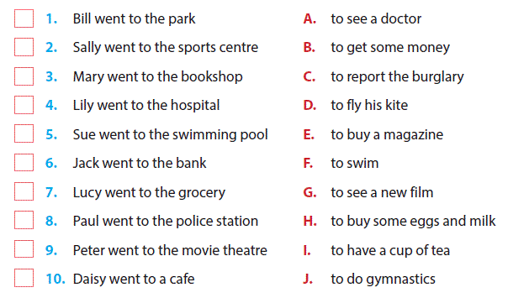

. CFill in the blanks with word" Will" or "Won't" According the chart (10 Pts)
 | Get married | Job | Live
Furkan |  | medicine | İzmir
Büşra |  | computer engineering | Eskişehir
Murat | X | teaching Maths | Adana
Azra |  | archeologist | Erzurum

- Furkan _____________ get married, study medicine and live in İzmir.
- Büşra ______________ be an archeologist and live in Adana.
- Azra _______________ live in Erzurum and be an archeologist.
- Büşra ______________ get married and live in Eskişehir.
- Murat ______________ live in Eskişehir and get married.

- Choose the correct answer. (14x4:56 points)
- Abdullah: Why don’t we eat ice cream?
Celal:……………. Ihave a sore throat.
- I’d love to but I can’t.
- Sure.
- Good idea.
- Let’s eat.
- Zehra: Shall we go to the cinema tonight.?
Sude: …………… Let’s meet at 7.00.
Zehra: OK.
  - I’m sorry, I can’t.
  - No, thanks.
  - Good idea.
  - No, thank you.
- Yusuf: ………….. goals did Cristiano Ronaldo score at the last match?
Mahmut: Three.
- How many b)How much
c) How often d)How old
- Furkan:…………….. water is there in the bottle?
Mert: Some.
- How many b)How much
c)How often d)How old
1.food | A. mum
2. party | B. parti
3. candle | C. kutlamak
4. celebrate | D. yiyecek
- Yukarideki kelimelerle anlamlarının doğru eşleştirilmesi hangisidir?
- 1-B 2-A 3-D 4-C
- 1-C 2-B 3-A 4-D
- 1-D 2-C 4-B 4-A
- 1-D 2-B 3-A 4-C
- Arda: When is the party?
Buğra: …………….
Arda: OK. I will be there.
- At my place
- At one o’clock
- A slumber party
- On 10th April, Tuesday
- Aşağidaki cümlenin sonuna aşağidakilerden hangisi gelemez?
I will be rich………..
- in the future
- in five years
- yesterday
- tomorrow
- Esra:What is your dream for the future?
Sümeyye :…..
- My trainers need washing.
- I will be an excellent doctor.
- It will be an interesting travel.
- I would like some ice cream.

(ANSWER THE QUSETIONS 9 AND 10 ACCORDING TO THE TEXT.)
Hi! My name’s Kadir. I always dream of being a famous football player. I will play for my favorite team, Galatasaray. I believe I will score a lot of goals and win lots of medals in my career. Also, I’ll earn a lot of money. So, I’ll help my family and poor people in my country. I hope these will come true.
- The text is about Kadir’s ……
- future problems
- family
- poor people
- dreams
- Which one is false?
- Kadir wants to be a well known footballer.
- Kadir believes he will be a successful footballer.
- Kadir will help poor people if he has a lot of money.
- Kadir will graduate from university.

- Anlam akışını bozan ifade hangisidir?
(I) I really enjoy seeing new places and learning about different cultures. (II) I think robot teachers will be in classrooms in the future. (III) I always dream of travelling around the world. (IV) I’ll be a famous traveler in the future.
a) I b) II c) III d)IV
My name is Ceyda. I have four pets – a dog, two kittens and a parrot. I really enjoy looking after them. I hope I’ll be a vet one day. Also I will be animal protector and I will provide animals a better life.

- Yukarıdaki metinde hangi sorunun cevabı yoktur?
- What is her name?
- How many pets does she have?
- What is her dream job?
- Where will she live?
- Mustafa Kemal Atatürk founded the Turkish Republic … 29th October…..1923.
- on / in b) at / in
c) in / at d) in / on
- My little brother is only 5 years old. He likes watching …………..
- cartoon b) news
c)documentary d) soap opera

CEVAP ANAHTARI :YOUTUBE ……………

