8TH GRADES 2nd TERM 2ND ENGLISH EXAM
NAME: NUMBER:
SURNAME: CLASS:

- Resimlerle kelimeleri eşleştiriniz ( 2x5 =10 points)
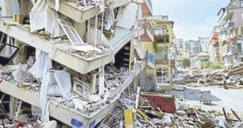
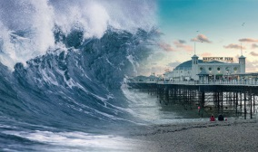
1.TSUNAMI

2.FLOOD

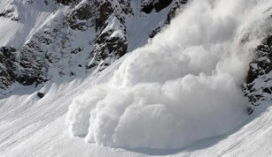
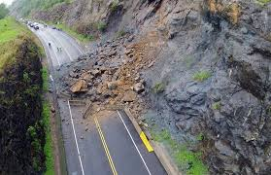

3.LANDSLIDE

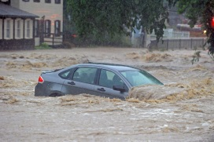
4.EARTHQUAKE

5.AVALANCHE

B)Fill in the blanks with “MUST” OR “MUSTN’T”.(4x5=20 pts.)

- We …………………………..cut down trees to prevent the environment.
- People ………………………….stop wasting water to prevent drought.
- We ………………………….be responsible for preventing our environment.
- We …………………………… talk each other during the lesson.
- If a scientist wants to make contributions to science , he …………………… invent something useful.

C) Verilen kelimelerin Türkçe karşılığını yazınız.(2x10=20 pts.)

1.water shortage
2.Air pllution
3.overpopulation
5.deforestation
4.Toxic waste
6.products
8.melt
7.transform

10.chemist
9.stem cells

D ) Read and answer the questions.( 5x5=25)
Drought is one of the natural forces and disasters. It happens when we don’t have enough rainfall and we waste too much water. We should use the water more efficiently. We should stop wasting our water sources. We should never pollute the rivers, lakes and seas. There should be programs to educate people on saving water. If we don’t take the necessary measures soon, we won’t have enough water to preserve and protect human life in the future.

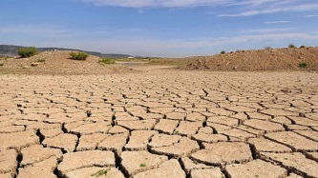

- What is drought?
- Why does drought occur?
- What should we do to prevent it?
- How can we educate people on saving water?
- If we don’t take the necessary measures what will happen in the future?

F) Metni tekrar okuyunuz ve aşağıdaki cümleler doğru ise TRUE, yanlış ise FALSE yazınız.( 5x5 = 25)

It happens because of rainfall
Drought is a natural disaster

TRUE
FALSE
FALSE
TRUE

We shouldn’t waste water
We should warn people

TRUE
FALSE
TRUE
FALSE

We should pollute the rivers

FALSE
TRUE

