ADI SOYADI

SINIFI NUMARASI

1
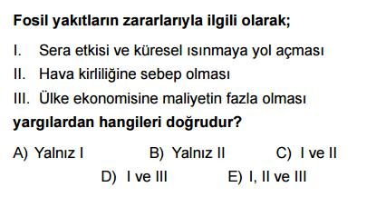

2
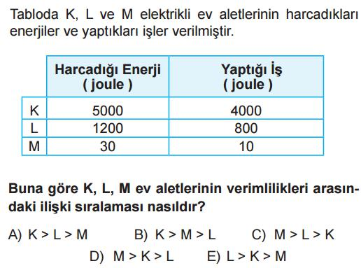

3
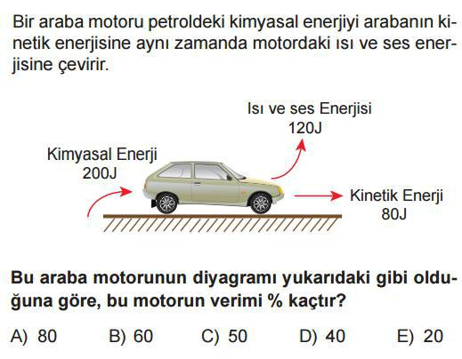

4
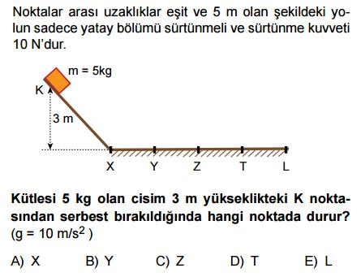

5
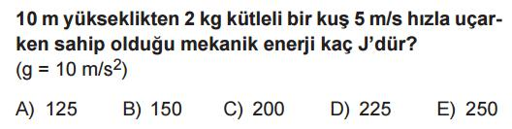

FKGAL FİZİK 09 / 2017-2018 BAHAR 2. SINAVI

6
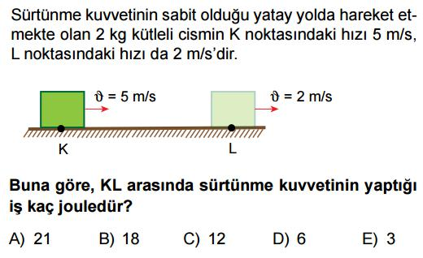

7
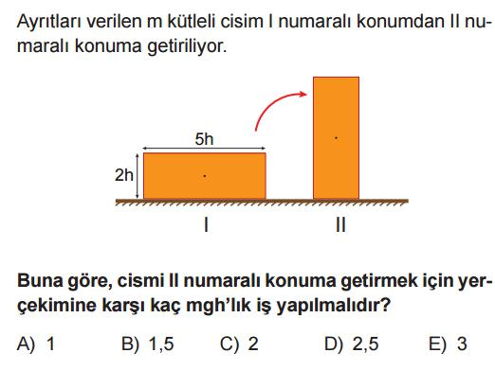

8
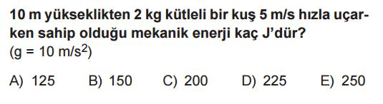

9
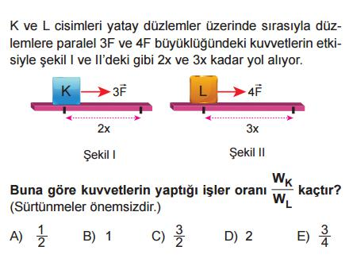

10
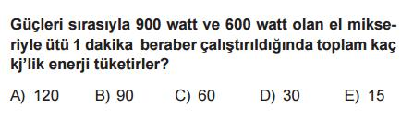

11
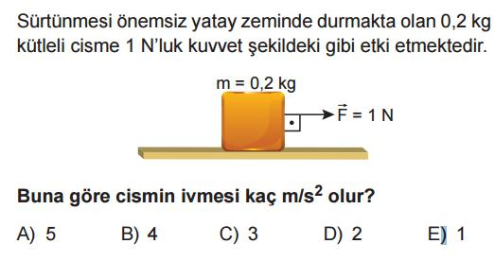

B

B

12 16
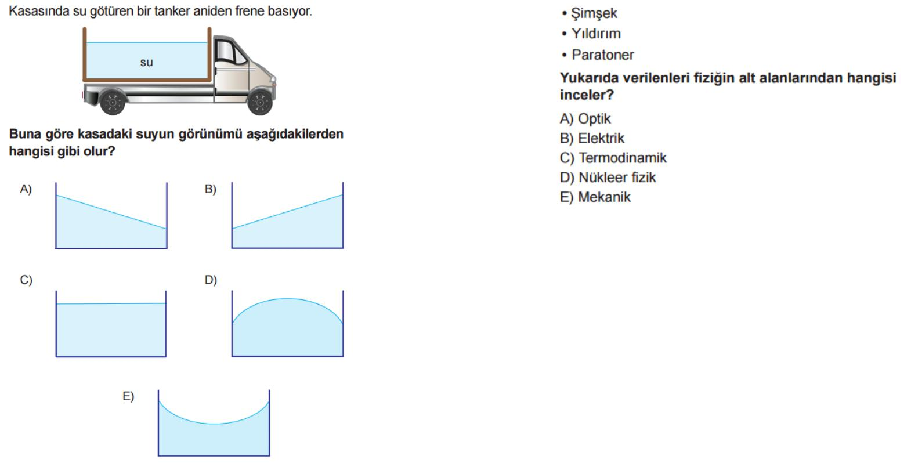

17
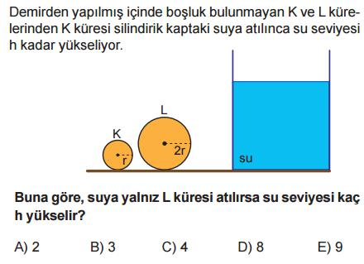

13
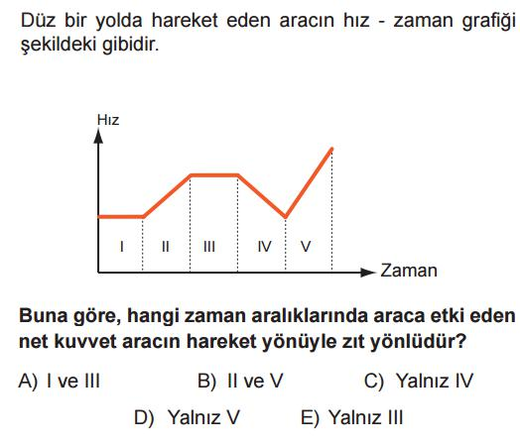

18
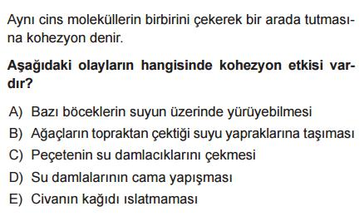

19
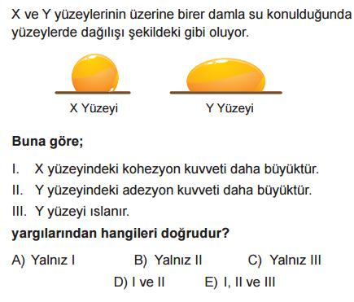

14
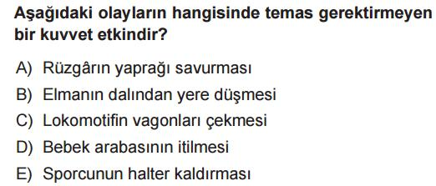

15
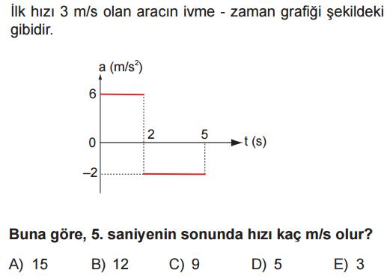

20
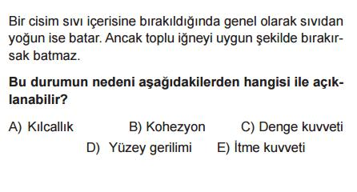

B
CEVAP ANAHTARI

1 | A | B | C | D |  | E
2 | A | B | C | D |  | E
3 | A | B | C | D |  | E
4 | A | B | C | D |  | E
5 | A | B | C | D |  | E
6 | A | B | C | D |  | E
7 | A | B | C | D |  | E
8 | A | B | C | D |  | E
9 | A | B | C | D |  | E
10 | A | B | C | D |  | E
11 | A | B | C | D |  | E
12 | A | B | C | D |  | E
13 | A | B | C | D |  | E
14 | A | B | C | D |  | E
15 | A | B | C | D |  | E
16 | A | B | C | D |  | E
17 | A | B | C | D |  | E
18 | A | B | C | D |  | E
19 | A | B | C | D |  | E
20 | A | B | C | D |  | E

ENGİN BÜYÜKÇELEBİ

FİZİK ÖĞRETMENİ

www.HangiSoru.com

