EDUCATION YEAR 2nd TERM 2nd SELECTIVE ENGLISH WRITTEN EXAM
FOR 5th GRADE OF 70. YIL HÜSEYİN ÖZTÜRK SECONDARY SCHOOL
Name : | Class : | Date: 08/05/2015
Surname : | Number: | Mark :
- Davetiye kartına göre cümlelerin karşısına “true” veya “false” yazınız.(5x2=10 pts.)
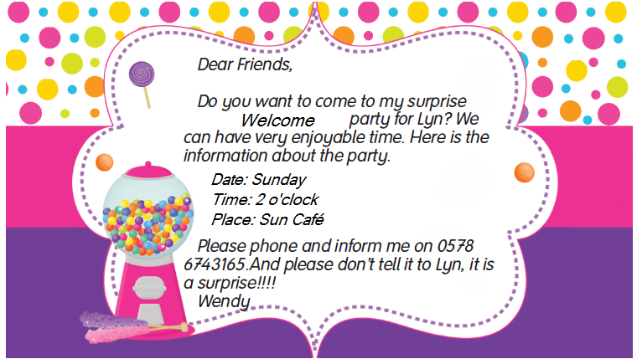

- Theparty is on Saturday. ___________
- It is a birthdayparty. ___________
- It is in SunCafe. ___________
- It is a surprisepartyforLyn. ___________
- Wendy’sparty is at threeo’clock. ___________
- Aşağıdaki diyaloğu, verilen ifadelerle tamamlayınız.(4x4=16 pts.)
-It is at myhouse. –It is at halfpasttwo. –I wouldloveto. – It is tomorrow.
Alfred: HelloTony.Howareyou?
Tony: I am veryexcitedbecause I have a birthdayparty.
Alfred: Great. When is it?
Tony: _________________________
Alfred:What time is it?
Tony: _________________________
Alfred:Where is theparty?
Tony: _________________________
Alfred:Happybirthdaytoyou, Tony.
Tony:Thankyouverymuch.Wouldyouliketocometomyparty?
Afred:Really? _________________________
Tony: OK,then.Seeyoutomorrow.Bye.
Afred: Goodbye.
- Aşağıdaki keliemelerle resimleri eşleştiriniz.(8x2=16pts.)
lion – elephant – chicken – crocodile – horse – cow – sheep -parrot
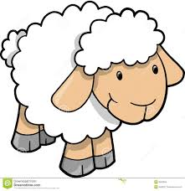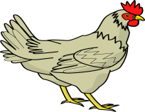
………………………….. ……………………………….. ………………………………… ………………………………

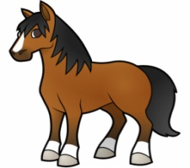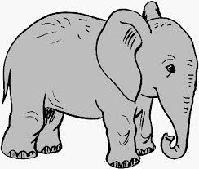
………………………….. ……………………………….. ………………………………… ………………………………….
- Aşağıdaki ayları doğru mevsimin altına yazınız.(12x2=24 pts.)
January – August – February – June – September – November – March – October – May – July – December – April
SPRING | SUMMER | AUTUMN | WINTER

- Doğru seçeneği işaretleyiniz.(6x3=18 pts.)
- the / go / to / Let’s / cinema
Verilen kelimelerin doğru sıralaması nasıl olmalıdır?
- Let’s to the cinema go. c) Let’s cinema the go to
- Let’s go to the cinema. d) Let’s to go the cinema.
- A: ____________ fitness activity do you like?
B: I like jogging.
- What b) When c) What time d) Where
- Andy: I’m hungry.
Mark: _____________ eating at that restaurant?
- Can b) Should c) Let’s d) How about
- Sam: Does your father like camping?
Barbara: ________________________
- Let’s go camping. c) My favourite activity is camping.
- Yes, he does. d) No, I don’t.
- I hate ______________ horror films.
- watching b) watches c) to watch d) to watching
- She watches Pepee ___ the morning.
- on b) at c) from d) in
- Aşağıdaki kelimelerin Türkçe anlamlarını yazınız.(8x2=16 pts.)
- snake: 5) weight lifting:
- tiger: 6) skiing:
- of course: 7) honest:
- welcome: 8) boring:

