NAME SURNAME : CLASS/NUMBER: MARK:
- WRITE THE CORRECT WORD UNDER THE PICTURES (4x5: 20 PTS)

Ride a bike | Climb mountains | Run | Swim

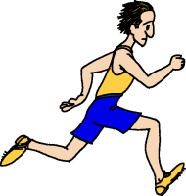 | 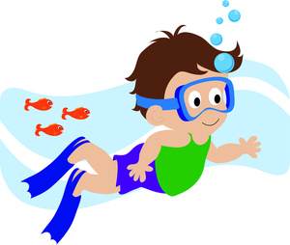 | 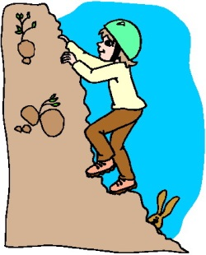 | 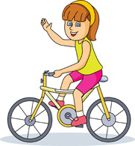
………………….. | ………………….. | ………………….. | …………………..

- ANSWER THE QUESTIONS ACCORDING TO THE TABLE BELOW (4x5:20 PTS)
(Yes, I can. / No I can’t)
YOU
can | can’t
run | ski
swim | play basketball
ŞENAY : Can you run?
YOU : ………………
ŞENAY : Can you ski?
YOU : ………………
ŞENAY : Can you swim?
YOU : ………………
ŞENAY : Can you play basketball?
YOU : ………………

- WRITE THE CORRECT WORD UNDER THE PICTURES (4x5: 20 PTS)
Milk the cows | Collect the eggs | Feed the sheep | Ride a horse

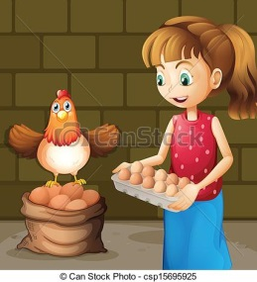 | 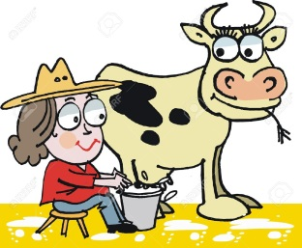 | 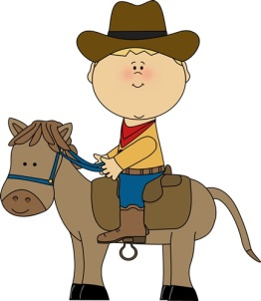 | 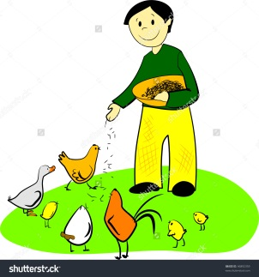
………………….. | ………………….. | ………………….. | …………………..

- WHAT ARE THE ANIMALS DOING (4x2.5: 10 PTS)
running | flying | swimming | jumping

- 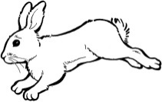The rabbit is ………
- 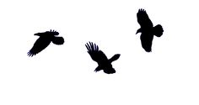The birds are ……….
- 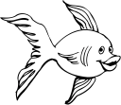The fish is …………….
- 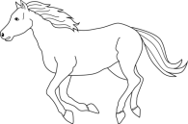The horse is ………….

- MATCH THE ANİMALS WITH THE PICTURES OF THEM (6X5=30PTS)

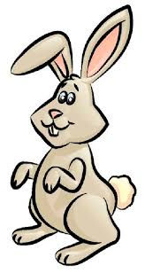
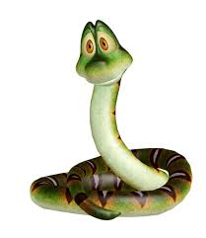

- Giraffe
- Sheep
- Puppy
- Rabbit
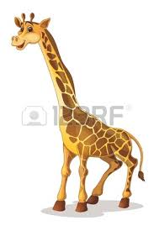
- Animal Shelter
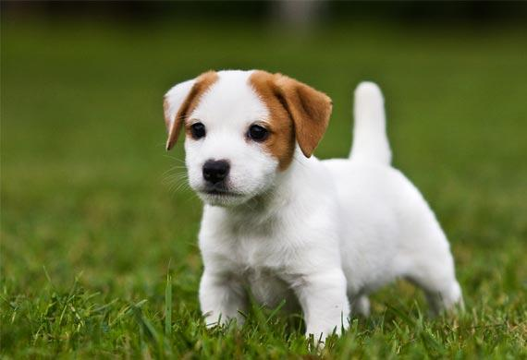
- Snake

