ELEKTİRİK
- 2009-7- SINF -SBS
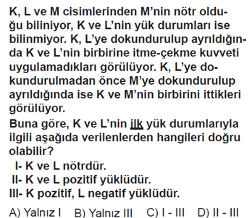
2-2014-7-SINF-PYBS
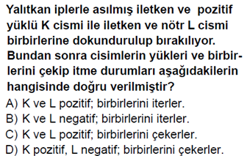
3-2005-6-SINF-DPYBS
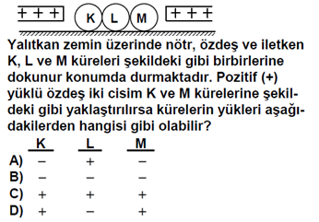
4-2003-6-SINF-DPYBS
5-2013-7-SINF-PYBS
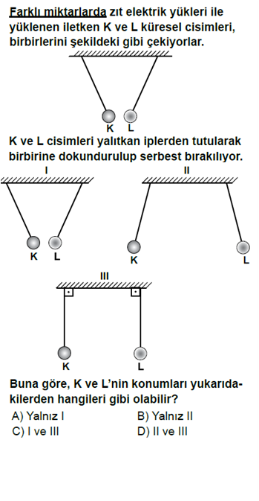
6-2004-6-SINF-DPYBS
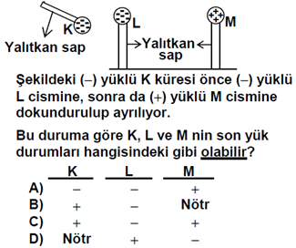
7-2005-6-SINF-DPYBS
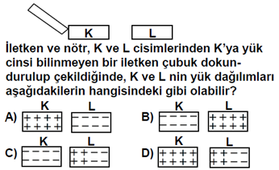

8-2013-7-SINF-PYBS
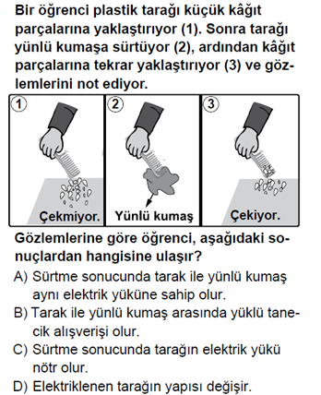
9-2004-6-SINF-DPYBS
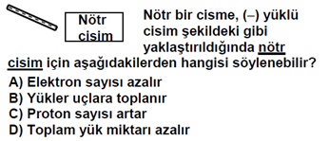
10-2006-OKS
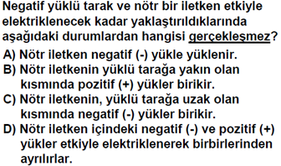
11-2012-7-SINF-PYBS
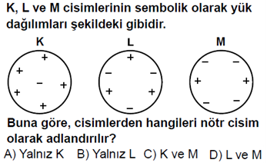
12-2002-LGS
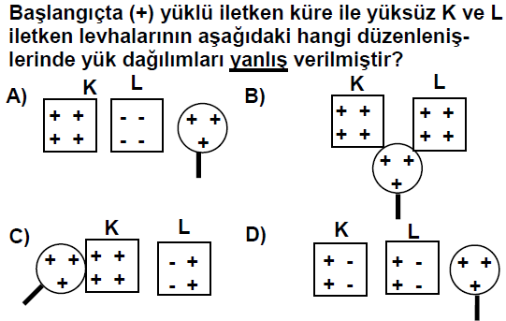
13-2005-6-SINF-DPYBS
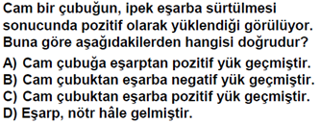
14-2005-6-SINF-DPYBS
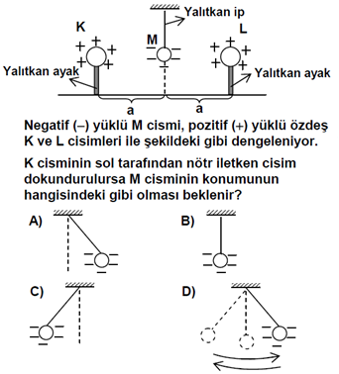
15-2002-6-SINF-DPYBS
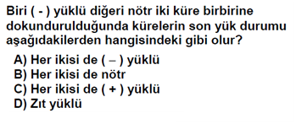

1-B
2-A
3-A
4-A
5-B
6-C
7-C
8-B
9-B
10-A
11-B
12-A
13-B
14-A
15—A
https://www.derskitabicevaplarim.com

