**5. SINIF SEVİYE TESPİT SINAVI**

<https://www.derskitabicevaplarim.com>

|  |  |
| --- | --- |
| Student’s name:**..................**  Number: **..................** | Mark: |
| Teacher: **HATİCE GÜNAY** |

**1) What is the weather like in Bursa?**

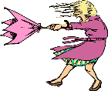**A)** It is sunny.

**B)** It is foggy.

**C)** It is rainy.

**D)** It is windy.

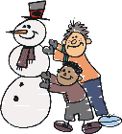

**2) ).................are** *winter* **months.**

**A)** February/March/April

**B)** June/July/August

**C)** September/October/November

**D)** December/January/ February

**3) My favourite fruit is .......................**

**A)** lemon

**B)** cherry

**C)** watermelon

**D)** strawberry

**4)**

**A) B)**

**C) D)**

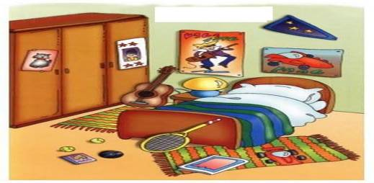**5)**

**This is my …………………….**

**A)** Kitchen **B)** Living room

**C)** Bedroom **D)** Bathroom

**6) I’m Brown and I have got two long arms and legs.My favourite fruit is banana.Who am I?**

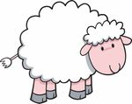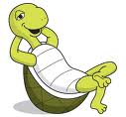

**Boşluğa gelecek uygun seçenek hangisidir?**

**A) B)**

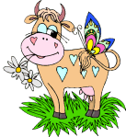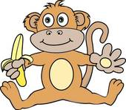**C) D)**

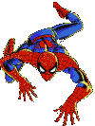

**7) What is his name?**

**A)** Her name is Spiderman.

**B)** He is Spiderman.

**C)** My name is Spiderman.

**D)** They are Spiderman.

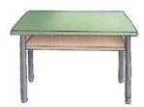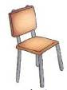

**8) The chair is...................the tables**

**A)** behind **B)** between

**C)** under **D)** next to



**My favourite subject is.....**

**9)**

**A)** Art **B)** Science

**C)** Social Science **D)** Music

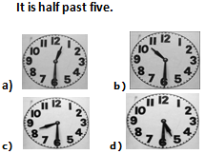

**10)**

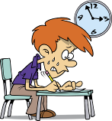**11)** *“Clean the classroom”*



**A) B)**

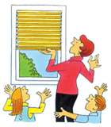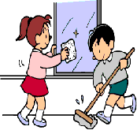

**C) D)**

**Hangi vücut organı** *yanlış* **verilmiştir?**

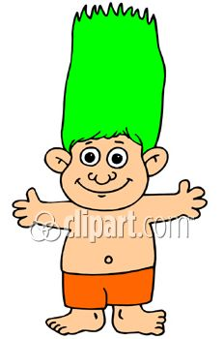

**12)**

**A)** hand **B)** hair

**C)** eye **D)** foot

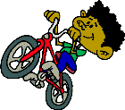**13) My brother has got** *a kite.*

**A)** **B)**

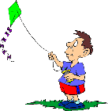

**C) D)**

**Doğru olan resim hangisidir bulalım.**

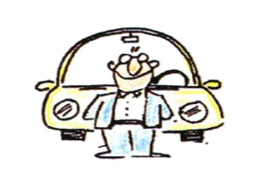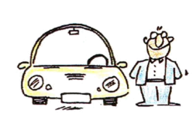**14) Hakan is** *on*  **the car.**

**A) B)**

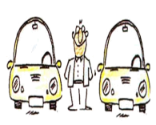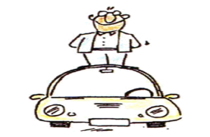

**C) D)**

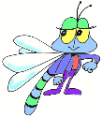

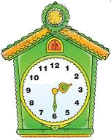

**15) What time is it?**

**A)** It is three o’clock

**B)** It is half past three**.**

**C)** It is eleven o’clock

**D)** It is half past two.

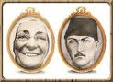

**16) Atatürk is Zübeyde Hanım’s……....**

**A)** father **B)** mother

**C)** son **D)** grandfather

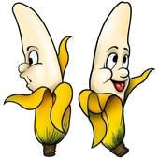**17) Bananas are** ..................

**A)** black **B)** orange

**C)** yellow **D)** green

**18) Is this a pencilcase?**

**A)** Yes, it is.

**B)** No, it isn’t.

**C)** I am fine.

**D)** No, she is.

**Aşağıdaki kıyafetlerden hangisi** *yanlıştır***?**

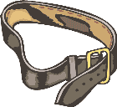**19)**

**A) B)**

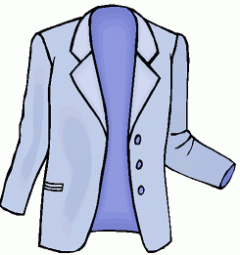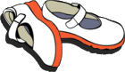**C) D)**

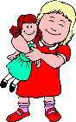

**20) I have got a**..................

**A)** train **B)** teddy bear

**C)** doll **D)** plane

**21) My uncle has got** *a donkey*

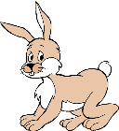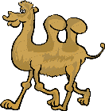**A) B)**

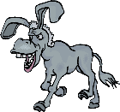**C) D)**

**22) What is the weather like today?**



a) It is hot and rainy. b) It is cold and sunny.

c) It is hot and sunny. d) It is warm and windy.

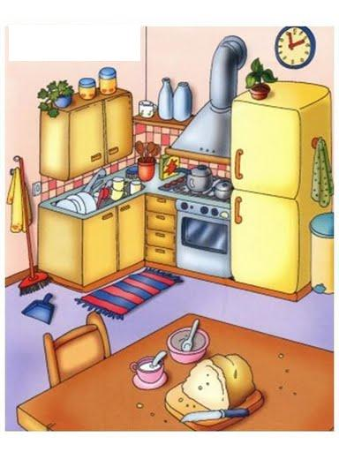**23) What is this?**

**A)** It is a fork **B)** It is a glass

**C)** It is a fridge **D)** It is a cup

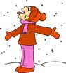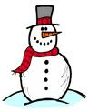

**24)**

a) It is hot. Take your cap.

b) It is sunny. Take your sun glasses.

c) It is rainy. Take your gloves.

d) It is snowy. Take your gloves.

**25) Monday, Tuesday**...........,**Thursday**

**A) B)**



**C) D)**

I’m ………………….

Give me some water please!

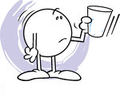**26)**

A.hungry B.fine C.thirsty D.happy

**I’m ten years old**

**27)**

a) What is the day? b) What time is it?

c) How are you? d) How old are you?

**28) There is a bathtub in the bathroom**

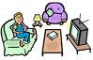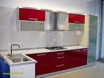

**A) B)**

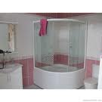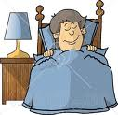

**C) D)**

**29)**

**It has got two eyes and three teeth. It hasn’t got ears and arms. It has got a tail.**

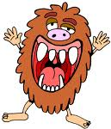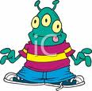

1. 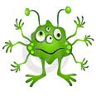 **b)**

1. 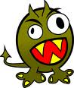 **d)**

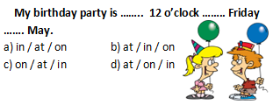**30)**

**31)**

……………………

I’m 11 years old.

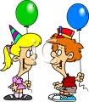

**a)** When is your birthday?

**b)** How old are you?

**c)** How are you?

**d)** What time is it?

**32) Boşluğa uygun seçenek hangisidir?**

There are …………………. apples .

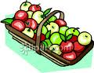

**a)** some **b)** a lot of

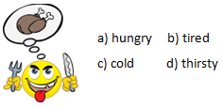 **c)** a **d)** five

**I’ve got Science on Friday.**

**33)**

A.  B.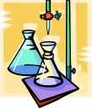

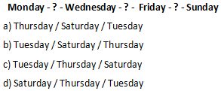C.  D. 

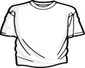 **34)** **It is cold and snowy. Put on your………….**

a) b)

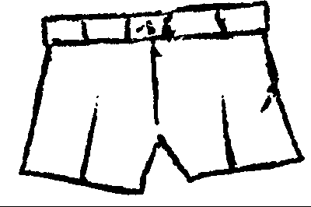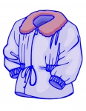

c) d)

.

**.35)**

1. 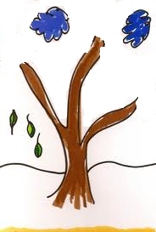Fall
2. Winter
3. Spring
4. Summer

**36)What is the day today ?**

A.It is a book. B.My birthday is in August.

C.It’s ten o’clock. D.It’s Monday.

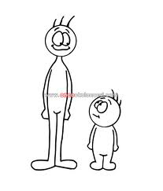

**37) Ali is …………but Veli is………….**

A) Ugly Beautiful

B) Fat Thin

C) Small Big

D) Tall Short

**38)**

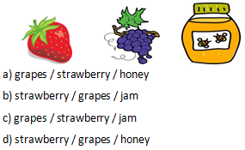

|  |  |  |  |  |
| --- | --- | --- | --- | --- |
|  | A | B | C | D |
| 1 | О | О | О | О |
| 2 | О | О | О | О |
| 3 | О | О | О | О |
| 4 | О | О | О | О |
| 5 | О | О | О | О |
| 6 | О | О | О | О |
| 7 | О | О | О | О |
| 8 | О | О | О | О |
| 9 | О | О | О | О |
| 10 | О | О | О | О |
| 11 | О | О | О | О |
| 12 | О | О | О | О |
| 13 | О | О | О | О |
| 14 | О | О | О | О |
| 15 | О | О | О | О |
| 16 | О | О | О | О |
| 17 | О | О | О | О |
| 18 | О | О | О | О |
| 19 | О | О | О | О |
| 20 | О | О | О | О |
| 21 | О | О | О | О |
| 22 | О | О | О | О |
| 23 | О | О | О | О |
| 24 | О | О | О | О |
| 25 | О | О | О | О |
| 26 | О | О | О | О |
| 27 | О | О | О | О |
| 28 | О | О | О | О |
| 29 | О | О | О | О |
| 30 | О | О | О | О |
| 31 | О | О | О | О |
| 32 | О | О | О | О |
| 33 | О | О | О | О |
| 34 | О | О | О | О |
| 35 | О | О | О | О |
| 36 | О | О | О | О |
| 37 | О | О | О | О |
| 38 | О | О | О | О |
| 39 | О | О | О | О |
| 40 | О | О | О | О |
|  |  |  |  |  |
|  |  |  |  |  |