İNGİLİZCE

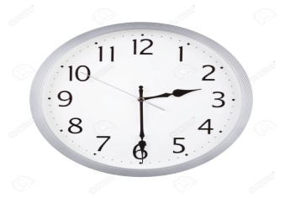 | 1. John : What time is it?  George: ______________________________ .

a) | It is two o'clock.
b) | It is quarter past two.
c) | It is quarter to two
d) | It is half past two.

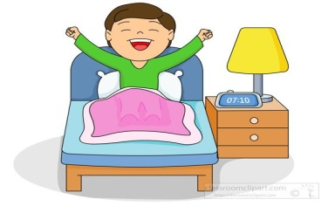 | 2. Tom __________________at ten past seven in the morning.

a) | Has dinner | b) | Gets up | c) | Washes his face | d) | Gets dressed

3. I like watching ______________ movies because they are very exciting.

a) | Comedy | b) | Sci-fi | c) | Western | d) | Animation

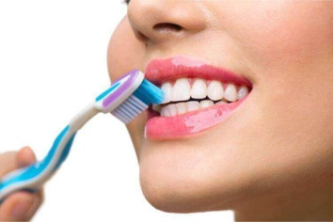 | 4. Sarah ____________ her teeth every morning.

a) | Brushes | b) | Gets | c) | Takes | d) | Has

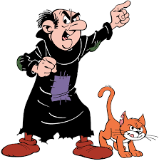 | 5. Gargamel is a ___________ and rude movie character. Some children  don't like him.

a) | Good | b) | Beautiful | c) | Evil | d) | Lazy

6. Sophia : What is your favourite movie?
Emily : It is Harry Potter and Philosopher's stone.
Sophia : ______________________________
Emily : It is about a young boy called Harry potter. He has special powers. He can do magic.
a) | What kind of movie do you like?
b) | What is it about?
c) | What time is it on?
d) | Who is your favourite movie character?

7. Oliver : Oh! I feel terrible.
a) | I am happy
b) | Enjoy your meal
c) | Good Luck
d) | Get Well Soon
Lucas : What is the matter with you?
Oliver : I have a headache.
Lucas : __________________________ .
Oliver : Thank you .
Lucas : You're Welcome.

a) | Go to the dentist
b) | Drink lemon and mint tea
c) | Carry heavy things
d) | Use a plaster

8. Emma : I have a sore throat. What should I do?
Mia : You should __________________.

9. Isabella enjoys __________________ .

a) | Sculpting | b) | Skipping rope | c) | Collecting stamps | d) | Doing origami

10. 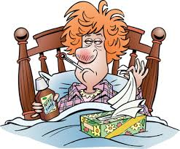 | James : What is the matter with her?  Lucas : She has ____________________ .

a) | A toothache | b) | A stomachache | c) | The flu | d) | A backache
https://www.derskitabicevaplarim.com

