A. Sorulara tabloya göre cevap verin.(5*2=10P.)
Ankara | 15°C | 
İstanbul | 21°C | 
Niğde | 11°C | 
Samsun | 18°C | 
Ağrı | -2°C | 
Gaziantep | 38°C | 
Tekirdağ | 9°C | 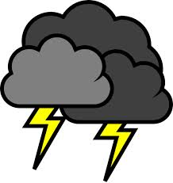

- What’s the weather like in Ankara?
…………………………………………………………..
- Is it snowy or rainy in Samsun?
…………………………………………………………..
- What is the temperature in Ağrı?
……………………………………………………………
- Which is colder? Ankara or Niğde?
……………………………………………………………
5. How is the weather in İstanbul?
……………………………………………………………

B. Parçaya göre cümleleri doğruysa TRUE, yanlışsa FALSE olarak işaretleyin.(5*2=10P.)

Suat: What do you think about the funfair?
Halil: I think it is funny.
Burak: I agree.I like the ghost train very much.
Kerem: I think ghost tarins are frightening.
Halil: I don’t think so.The roller coaster is more frightening.It’s really dangerous.
Burak: I like roller coasters.They are exciting ,but I hate caroussels.They are boring.
Halil: I don’t agree.Caroussels are fantastic!
Kerem: I agree with you Halil.

- Halil thinks the funfair is horrible.________
- Burak and Kerem like ghost trains.________
- Kerem thinks ghost trains are boring.______
- Halil thinks roller coasters are more frightening than ghost trains._______
- Halil and Kerem likes carousels.________

C.Resimlerle kelimeleri eşleştirin.(5*1=5P.)
ROLLER COASTER – WAVE SWINGER – GHOST TRAIN – CAROUSSEL – BIG WHEEL
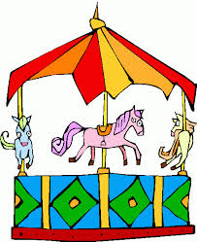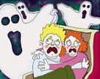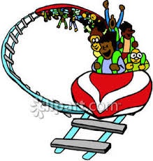

-------------- ------------ ------------- ------------------- ---------------

D. Doğru cevapları işaretleyiniz.
(25*3=75P.)
1. Merve: ……………………………………………………?
Kenan: It is cold and snowy.
a) What time is it?
b) What’s the weather like in Erzurum?
c) Where are you from?
d) How often do you go to cinema?
2. We can go swimming today because ……………………
a) I am scared b) It is snowy
c) I feel tired d) It is sunny
……………….….
3. 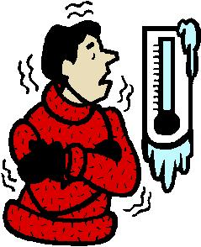
a) It is hot and sunny.
b) It is stormy here today.
c) It is freezing cold.
d) It is rainy and wet.
4. Take your umbrella it’s……….. outside.
a) sunny b) raining c) snowy d) windy
……………………… when it’s stormy.
5. 
a) I feel happy b) I am sleepy
c) I feel scared d) I am fabulous

6. A cheetah is ……………………… than a lion, but it is not stronger ……………………… a cheetah.
a) faster / with b) fast / and
c) taler / then d) faster / than

7. Carol: ………………………………………………………………?
Amy: She’s in the kitchen. She’s preparing lunch.
a) What time do you have lunch
b) What do you have for lunch
c) Where is your mother
d) What does your sister do after school

8. I haven’t got ………………… money on me.
Is there ………… bank near here?
a) some / an b) any / any
c) any / a d) a / a

9. Seçil: …………… are you doing?
Yelda: I’m listening to music.
a) Where b) What c) How d)What time

10. Semih:……………some croissants?
Nevin:No,thanks,………………..
a)Do you want/would like
b)Would you like/like
c)Want/ I’m full.
d)Enyoy your meal/ want
https://www.derskitabicevaplarim.com
11.Burak always gets up ……….7.30 ……. Weekdays.
a) in/on b) at/ on c) at/in d) on/in

12. Selin: What ……. You do after school?
Murat: I usually ………my homework.
- Do/does b)is/make c)do/do d) are/do

13. I always ………… breakfast ………… the mornings.
a) have/at b)have/in c)has/at d)has/in

14. Melek: What ……your sister doing?
Seçil: She ……………the Street cats.
a)is/is feeding b) are/feeds
c)does/is feeding d) do/feeds

15.Kelime grubunda anlamca dışarıda kalanı işaretleyin.
a) stormy b)cloudy c)rainy d)moody
16. Ali is riding the wave swinger at the ………..

a)school b)funfair
c)camp d)canteen


17.I feel moody on …………… days.

a) rainy b)freezing
c) cold d)foggy

18. I don’t like city life because cities are ……………………… and…………………..
a) quiet/crowded b)easy/difficult
c)tired/happy d)crowded/noisy

19. Lale: I think roller coasters are crazy.

Tülay:I don’t ………….with you.They are horrible!

- answer b)think
- agree d) prepare

20. Jale: ……………………………………………………..?
Melih: I think they are funny.
- Where are you going now?
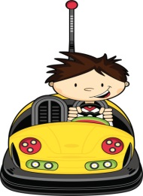
- What do you think about fıunfairs?
- Where do you live?
- When is the party?
21. ………………………….. is my favourite!

a) bumper car b)caroussel
c) ghost train d)big Wheel

22.My favourite food is………………….Yummy!
a) online b)meal c)spaghetti d)dinner


23. Resimdeki yiyeceğin adı nedir?
a) sausages b)bagels
c) pancake d)muffin

24. I feel ……………. , because it’s ……………… today.

a) moody/foggy b)happy/sunny
c) scared/windy d)upset/snowy

25. My birthday is …… 4th October 1983.
a) on b)in c)at d)with

