1) We can go on a picnic today because ……..
a) I feel scared b) It is snowy
c) I feel tired d) It is sunny

2) Boşluğa hangi kelime gelmelidir?
The city is ...........than the country.
a) crowded b) crowding
c) more crowded d) crowder

3) I feel ………on foggy days, I go to bed and sleep.
a) anxious b) happy c) sleepy d) scared

4) Ali : Would you like to eat bagel?
Alp: ................., I don’t like it.
a) Yes,yummy b) No,thanks
c) Yes,please d) I like

5) Tom: Everything is verydelicious. Thankyou
Sophie: Bon appetit!
Sophie’nin kullandığı ifadenin eş anlamlısı hangisidir?

a) Yummy b) Enjoy your meal
c) I’m full d) You are wellcome

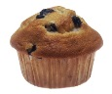
6) I have ………….. at breakfast.
a) cheese b) croissants
c) muffin d) bread


7) What time is it?
a) It is four o’clock.
b) It is half past five.
c) It is quarter past four.
d) It is half past four.

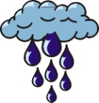
8)What is the weather like?
a) It is rainy.
b) It is foggy.
c) It is windy.
d) It sunny and cloudy.

9) Cem : It is rainy and stormy in Sinop.
Mert : ..........................................
a) Wear your sunglasses
b) Use your sun cream
c) Eat your breakfast
d) Take your umbrella

10) Sude : What do you think about carrousel?
Ayça : ......., it is fantastic.I love it.
a) I think b) I’m sorry c) I’m bored d) I agree

11) Rana : ............................................?
Esen : It is eighteen degrees Celcius.
a) How is the weather? b) How do you feel?
c) What is the weather? d) What’s the temperature?

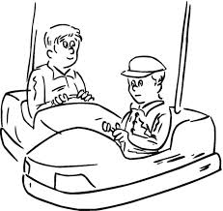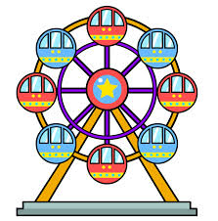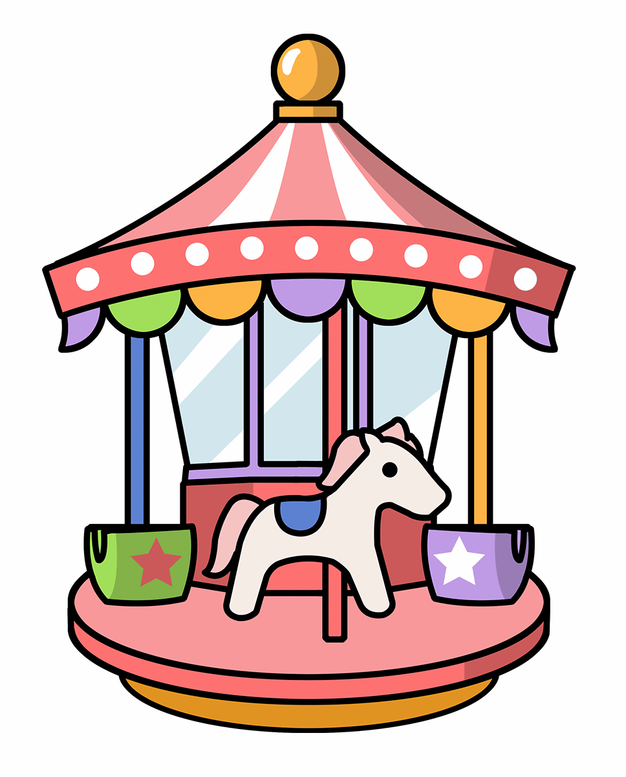
12) Aşağıdakilerden hangisinin yukarıda resmi yoktur?
a) ghost train b) carrousel
c) bumper cars d) big wheel

13) Get on your horse. Gallop! Gallop! Gallop!

Yukarıda tanımı verilen eğlence aleti nedir?
a) chairoplane b) carrousel
c) bumper cars d) ghost train

14) Emrah likes drinking ………………… 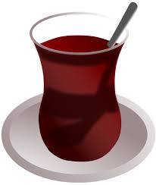

A. tea B.orange juice C. cola D. milk

The FUN Fair

15) Where is the fun fair?
a) It is in the fun fair. b) It is in May.
c) It is one token. d) It is in Freemont City.

https://www.derskitabicevaplarim.com

