Match the words with the pictures.
Shy – Strong – Slim – Stubborn – Selfish

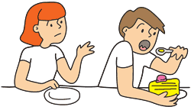
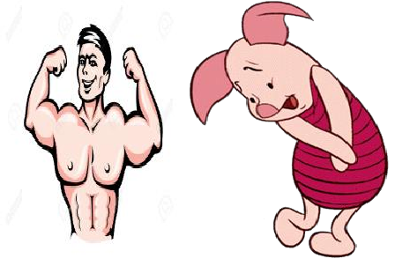
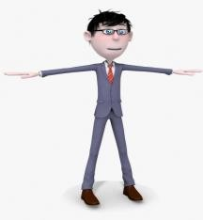
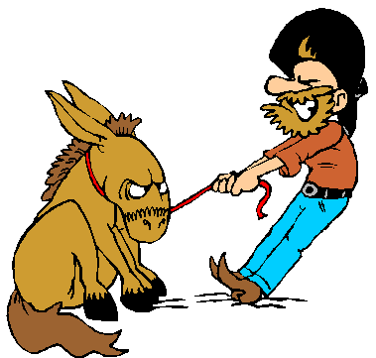

Fill in the blanks with the words below.
clumsy – punctual – forgetful – outgoing – generous

- Selda is a(n) girl. She has got a lot of friends.

- My sister often breaks something at home. She is really .

- I like people because they always help people and buy presents.

- My grandfather has difficulty in remembering things. He is .

- Emre often goes to school late. He is not a boy.

Match the questions with their answers

- What colour are your eyes ?

- Who is overweight in your class ?

- What does your favorite singer look like ?

- Is your deskmate a good friend ?

- Why do you support Ceren for class presidency ?
Oğuzhan. He is short and really fat. Yes, she is really easygoing.
I have got big,green eyes.

Because she is more honest than other candidates.
She has got long, straight, blonde hair.

Odd one out.

- attractive / beautiful / ugly / pretty

- curly / straight / wavy / young

- stubborn / friendly / outgoing / easygoing

- thin / kind / slim / tall

- strong / well-built / athletic / punctual

Write True (T) or False (F) about Bugs Bunny. What does Bugs Bunny look like ?
It is tall and slim.

It is short and overweight. It has got two big ears.
It has got long teeth.

It doesn’t have moustache.

Choose the correct option.

- My sister is very thin / fat. She is only 25 kilogrammes.

- I don’t like stubborn people. They never change their minds / help old people.

- My cousin has got long, curly , big / blonde hair.

- I go to the gym / bank every day because I want to stay fit.

- Esra is a talkative / shy girl. She always chats with her friends.

Match the words with the pictures.
Lawyer – School band – Moustache – Glasses – Junk food

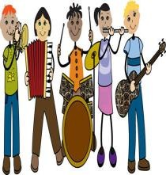
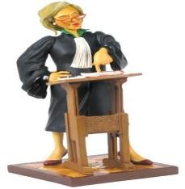

Match the questions with their answers.

- Who is your favorite actor ?

- What characteristics should a class president have?

- What does your father look like ?

- Are you a stubborn person ?

- When do you usually go to the gym?

He is tall and fat. He has got moustache. He is Robert Pattinson.
At weekends. Usually on Sundays. He/she should be honest and thoughtful. Yes, I never change my mind.

Correct the mistakes.

- My brother always tells lies. He is not a punctual boy.

- My ex-deskmate is very hardworking. She never revises for tests.

- I have got big hazel noses and short, dark, curly glasses.

- Recep İvedik is a comedy movie. It is really shy.

Put the adjectives into the correct boxes.

Clumsy – Thin – Handsome – Honest – Lazy – Ugly – Overweight – Strong – Kind – Attractive Slim – Clever – Talkative – Beautiful – Generous – Tall – Fat – Selfish – Easygoing – Thoughtful

APPEARANCE PERSONALITY

1.

2.

3.

4.

5.

6.

7.

8.

9.

10.

1.

2.

3.

4.

5.

6.

7.

8.

9.

10.

Find out the scrambled words.

EX : My deskmate (t a d k e s m e) is an athletic boy. He usually goes to the gym to stay fit.

- A class president should be ( a r i f ) and thoughtful.

- Sena has got big ( e r g e n ) eyes. They are beautiful.

- My best friend is very talkative but she is sometimes (d o l u ). I can’t stand her voice.

- Serdar is very generous. He usually pays our ( s e l a m ) at the restaurant.

- Aylin often comes to work late. She is not a ( t u p l u c a n ) woman.

https://www.derskitabicevaplarim.com

