1. **Hangisi bir televizyon programı değildir?**
2. Soap Opera
3. Remote controller
4. Series
5. Talk show
6. **Kutucukta özellikleri verilen kişi hakkında hangisi söylenebilir?**

* He doesn’t congratulate you on your success.
* He becomes unhappy when you have higher marks than him.
* He always criticize you.

1. He is generous
2. He is forgetful.
3. He is jealous.
4. He is clumsy.

|  |
| --- |
| **3-11. sorularda boş bırakılan yere uygun gelen seçeneği işaretleyiniz.** |

1. **Chris gets lower Marks at school……….he always surfs on the Net.**
2. Or C)But
3. So D) Because
4. **Ali: How often do you exercise?**

**Can:……………………………………**

1. At the moment
2. Twice a week.
3. It was even.
4. I go to the gym.
5. **Engin: In my dream , I saw a big cat.**

**Ecem: Sorry…………….. Can you repeat it , please?**

**Engin: I saw a big cat in my dream. It is bigger than a house.**

1. I couldn’t see it.
2. I was really afraid of it.
3. I didn’t understand you.
4. I couldn’t shout.
5. **Can :………..**

**Canan: I usually get up early. I take a shower and then I go to the school. After school I go to English courses.**

1. How do you spend your day?
2. Where do you want to go?
3. Why do you get up early?
4. Do you get up late?
5. **Doğukan: What does an elephant have?**

**Eren: It has………………………..**

1. Fur C) Beak
2. Wing D) Trunk
3. **Selim is a…………………person. Nobody likes him.**
4. Well-built C) generous
5. Selfish D)handsome
6. **Aslı …………………drawing and painting when she was a little child**.
7. began C) will begin
8. begin D) can begin
9. **my grandfather is………..my father.**

A)old C)older than

B)younger than D)older

1. **Manchester city……………….Bayern Munich 3-2 last week.**
2. lost C)trained
3. drew D)defeated
4. **İfadeye uygun düşen sporu bulunuz.**

**“In this game, there are two teams, Each team must have five players. Players mustn’t touch the ball with feet.”**

1. Football
2. Baseball
3. Basketball
4. Golf
5. **Resim ve kelime eşleşmelerinden yanlış olanı bulunuz.**
6. 

Spectators



Equipment

1. 

Team



Cup

1. **“ My friend Aylin is a funny person.She has got short curly hair.” Cümleye göre doğru olanı işaretleyin.**
2. 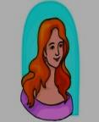 C) 
3. 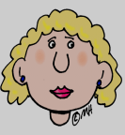 D) 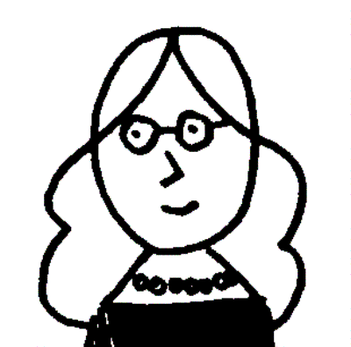
4. **The children…………….spend so much time in front of Tv.**
5. should C)does
6. can D)shouldn’t
7. **Verilen ifadelerle bir diyalog oluşturulduğunda sıralama nasıl olur?**

|  |
| --- |
| 1. Oh,ok. I can give it to you. 2. Ada, Can I ask you a question? 3. I am working hard and I need your computer because mine is broken. 4. Yes, of course. |

1

1. 2-4-3-1 C)3-4-1-2
2. 2-1-4-3 D)1-3-4-2
3. **Verilen kelimeler anlamlarına göre gruplandırıldığında hangisi bu grubun dışında kalır?**
4. Prize C) prey
5. Award D) meda

[https://www.HangiSoru.com](https://www.HangiSoru.com/)

|  |
| --- |
| **18-20. soruları parçaya göre cevaplayınız.** |

**WALT DISNEY**

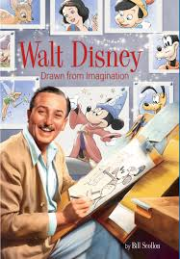Walt Disney was born on December 5, 1901. He is famous American businessman, cartoonist, animator and producer.

This ambitious man founded Walt Disney Productions together with his brother. In 1932, Disney received an Academy award for the creation of “Mickey Mouse”. His other extraordinary characters were Donald Duck, Goofy and Pluto. Eight years later after he won award, he went to Chicago and he built Amusement park. On Sunday, July 17, 1955 Disneyland was opened. Walter Disney became ill and he died in 1966.

1. **Which one *is not* true according to passage?**
2. Walt Disney is a famous cartoonist and an animator.
3. Walt Disney went to Chicago ten years later after he won award.
4. His brother and Disney founded Walt Disney Productions.
5. Walt Disney died 11 years later after he opened Disneyland.
6. **What happened in 1955?**
7. Walt Disney opened Disneyland.
8. Disney went to Chicago.
9. His brother and Disney founded Walt Disney Productions.
10. He died in 1955.
11. **Why did Walt Disney die?**
12. Because,Walt Disney had an accident.
13. He died because of fighting with his brother.
14. Disney died because of his wife.
15. Disney died because of illness.

ZEYNEP KURT

<https://www.derskitabicevaplarim.com>