**1) He…………….watching action films…..comedy**

A)prefers/to B)prefer/to

C)prefer/but D)prefers/but

**2) Mert prefers ……………bike to…………….car.**

A) ride / drive B) riding / driving

C) rideing / drive D) ride / driving

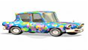[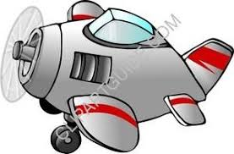](http://www.google.com.tr/imgres?imgurl=http://www.clipartguide.com/_small/0041-0701-2616-5444.jpg&imgrefurl=http://www.clipartguide.com/_pages/0041-0701-2616-5444.html&usg=__yJUjXhCBGIsuoEVNjPSIPf7P29c=&h=197&w=300&sz=11&hl=tr&start=1&um=1&itbs=1&tbnid=HUQHPZv_IcGhRM:&tbnh=76&tbnw=116&prev=/images?q=plane+cartoon&tbnid=HUQHPZv_IcGhRM:&tbnh=0&tbnw=0&um=1&hl=tr&sa=X&rlz=1R2WZPA_en&imgtype=i_similar&tbs=isch:1)

**3) A plane is ……………………………….. a car.**

A) the fastest B) the most fast

C) faster than D) more fast than

**I ………… eating spinach to hamburger.**

**4)**

A) likes B) wants C) prefer D) prefers

**5)**  **A mouse is ___________ than an elephant.**

A)smaller B)taller C)fatter D)bigger

**6) She ……………………………… in İstanbul yesterday.**

a) were b) are c) was d) is

**7) They ………………………………… the letters last week.**

a) sends b) sent c) sended d) send

**8) I ……………………………………… my father two hours ago.**

a) helps b) help c) helped d) helping

**9. ………………………………………… you see the cheetah yesterday?**

a) Does b) Did c) Is d) Was

**10) Did you open the door? No,I …………………………………… .**

a) wasn’t b) isn’t c) doesn’t d) didn’t

**11) 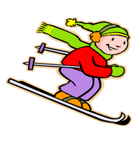 She always goes ……………. .**

a) skiing b) sailing c) baseball d)swimming

**12) …………you……….to cinema yesterday ?**

**a)** Do/go **b)**Does/go

**c)** Did/went **d)**Did/go

**13) I have a terrible toothache. ………………………………………… ? You should see a dentist.**

a) What did I do? b) What should I do?

c) What time? d) What do I do?

**14 ) A camel lives in the …………………..**

**a)**Jungle  **c)** desert

**b)**Forest **d)**zoo

**15 ) A:** **…………………………………………………………….**

**B:** He is clever optimistic and helpful.

**a)** What does he like?

**b)** What does he look like?

**c)** What is he like?

**d)** What does he do?

Good Luck !

<https://www.derskitabicevaplarim.com>