………….. ACADEMIC YEAR
……………….. HIGH SCHOOL 1ST TERM 1ST ENGLISH EXAM FOR 9TH GRADES
Name - Surname :................................
Class - Number :................................

A-Read the text and answer the questions below.Write true or false.
(Noktalı yerlere cümle dogruysa T, yanlışsa F yazınız) 4x2:8p
This is Omar. He’s from India. Omar is forty years old. He’s a pilot. His favourite sport is football.This is Mark and this is Julie. They’re married and they’re from America. Mark is twenty-nine years old and Julie is twenty-six years old. Mark is a postman and Julie is an artist. His favourite sport is basketball and her favourite sport is volleyball.

1- Omar is twenty-nine years old. …………… 2-Omar is a pilot. ……………
3-Julie is an artist. ……………. 4-Her favourite sport is volleyball …………..

B)Circle correct word.6x3:18p
( Altı çizili olan seçeneklerden doğru olanı yuvarlak içine alınız)
- We have/has got a house. It/Its is very big.
- This is Mary. She / Her is a student and she has / have got green eyes.
- Our /We eyes are black but they/their eyes are blue.
- Kate and Lucy are sisters. They have /has got two computers.
- Tom is I / my best friend. He / His is a lawyer.
- Our house has / have got 4 rooms
C-) Circle correct word.5x3:15p
( Altı çizili olan seçeneklerden doğru olanı yuvarlak içine alınız)

- There is / There are some posters on my walls.
- There isn’t / There aren’t a waste basket in my bedroom.
- There isn’t / There aren’t any maps on my table.
- There is / There are an alarm clock on the bedside table.
- There isn’t / There aren’t a laptop on my desk

D. Tabloyu İnceleyin. Boşluklara "have got / has got" veya "haven't got/ hasn't got" yerleştirin
4x3:12p
- I _____________________a dictionary.
- Lucy____________________ a camera.
- I and Lucy _______________cell phones.
- I ________________________ a bike.

 | Lucy | I
a camera | √ | x
a dictionary | √ | x
a bike | √ | √
a cell phone | X | x

E.Match them.(Sorular ve cevapları eslestir.soruların rakamlarını yaz.) 7x3:21p

1. Where are you from? _______ A)She is Mexican.
2. What’s your nationalıty? _________B)Nineteen.
3. What is your job? _______ C) He is from Turkey.
4. How old are you? _________ D) I am a teacher
5.What’s her nationalıty? _________E)I’m from Portugal.
6.Where is Ahmet from? _________F)She is an engineer.
7.What does Burcu do? _________G)I’m Turkish.

F) Choose the best answer.( Doğru cevabı işaretleyiniz) 4x3:12p
1. A lion is .............than a mouse
a)biggest b)more big c)big d)bigger
2. Antalya is ..........than Ankara.(hot)
a) hotter b) hottest c) hot d)more hot
3. Water is ..............than Cola
a) healty b) most healty c) more healty d) healtiest
4. My grades are ............than yours.(bad)
a) better b) good c)worse d) more bad

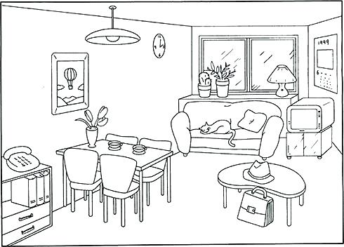
G. Look at the picture and complete the sentences with “in front of, under, on, between, near, in, behind’ (Boşlukları verilen resme uygun ve altı çizili verilen edatlara göre doldurunuz )7x2:14p
- The sofa is___________________ the window.
- A table is _____________________ four chairs.
- A lamp is _____________________the sofa.
- A hat is _____________________the coffee table.
- A drawer is _____________________ the dining table.
- A cushion is _____________________ the sofa.
- There are three books _____________________ the telephone.
GOOD LUCK
9TH GRADES ENGLISH TEACHERS

