2022-2023………………..Anatolian High School
9th Grades 1st Term 1stWritten Exam
Name – Surname:__________________________ Class:_______ Number:______

A) Classify the given words in the box.(20x1=20)
» Library
» Architect
» Mexico
» Shoe store
» Cousin
» Japan
» Sister
» Carpenter
» England
» Post office
» Husband
» Supermarket
» India
» Father
» Plumber
» Lawyer
» Greece
» Airport
» Wife
» Surgeon

Family
1._________________
2._________________
3._________________
4._________________
5._________________

Jobs
1._________________
2._________________
3._________________
4._________________
5._________________

Places
1._________________
2._________________
3._________________
4._________________
5._________________

Countries
1._________________
2._________________
3._________________
4._________________
5._________________

B) Match the questions with the correct answers. (10x2=20)

1.How many brothers have you got? a.Yes, there is.
2.How are you? b. I’m a student at a high school.
3.How old is he? c.I live in Istanbul.
4.Where is the shoe shop? d. Yes, I have.
5.Where do you live? e. It’s hot and sunny.
6.What do you do? f. I have one.
7.Is there a shopping mall in your city? g. No, I am not.
8.What’s the weather like? h. Not much.
9.Are you married? i. He is 15 years old.
10. Have you got any books in your bag? j. It’s between the café and the pharmacy.

C) Match the directions with the pictures.(5x3=15)
a. Take the second road on the right. b. Turn left c. Turn right
d. Go straight on. e. Take the first road on the left.
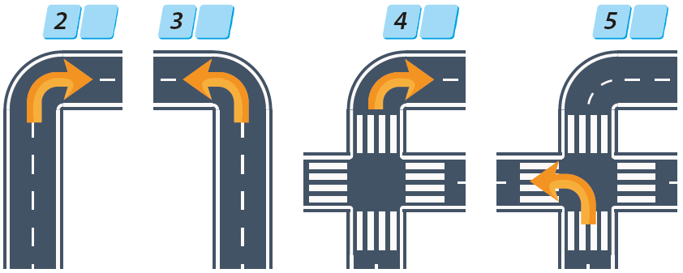

D) Look at the map and complete the sentences with the words given. (5x3=15)
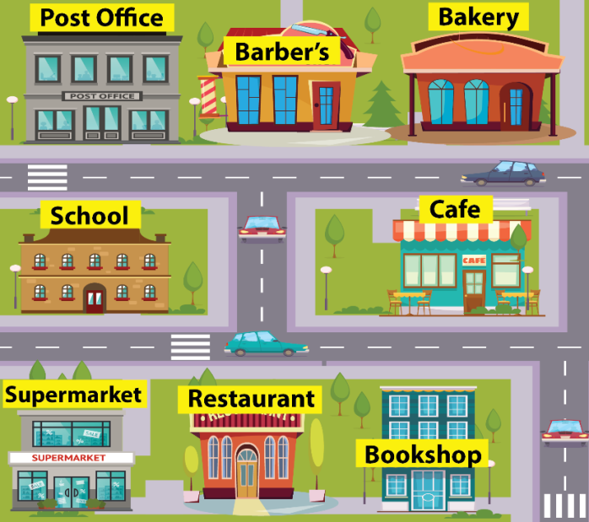
hospital – between – restaurant – café – next to

1. The Barber’s is ________________ the
bakery and the post office.
2. _______________ is opposite the bookshop.
3. The supermarket is _______________ the
restaurant.
4. There is a ________________ between the
bookshop and the supermarket.
5. There isn’t any _____________ on the map

E) Read the text and answer the questions.
This is Susan. She is an engineer at a big company. She is from London, Britain, but she lives in Barcelona. She is 29 years old. She is married and her husband is from Spain. She has got a son. Her son’s name is Mike. Susan can speak English and Spanish. She likes reading a book and watching movies in her free time.
(5x3=15)

1. How old is Susan?
2.Where does she live?
3. Where is she from?
4.Which languages can she speak?
5. What does she like?

F) Complete the blanks with comparative or superlative forms of the words in paranthesis. (5x3=15)
 | 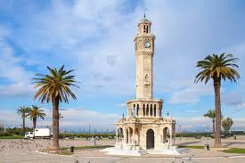  İzmir | 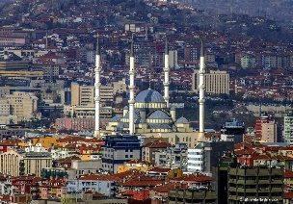  Ankara | 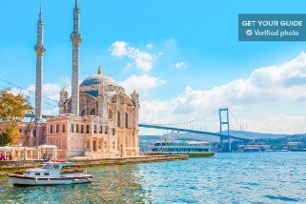  İstanbul
1.İstanbul is _____________________(crowded) İzmir.
2.İzmir is ______________________ (warm) Ankara.
3. İstanbul is ____________________ (big) city in Turkey.
4.Ankara is ________________________(expensive) İstanbul.
5.Ankara is _______________________ (important) city in Turkey.
GOOD LUCK

