Soru 1  Choose the correct option to complete the dialogue.  Arda: What are you doing this evening?  Yaman : Nothing special. Why?  Arda: There’s an award winning film on TV tonight. Shall we watch together?  Yaman: It sounds good. What’s its genre?  Arda: It’s a horror film. Do you like horror movies?  Yaman: Of course I do. ...... these kind of films. When is it on?  Arda: At 8 o’clock. Don’t be late.  Yaman: OK, see you then!  A) I’m really into  B) I can’t stand  C) I really hate  D) I dislike  E) I don’t like  Soru 2  Answer the question according to the information in the parenthesis.  What time do you get up? (08:30 a.m.)  A) At eight past thirty  B) At thirty to eight  C) At half past eight  D) At thirteen past eight  E) At thirteen to eight  Soru 3  Choose the correct option to complete the sentence.  A/an ...... can wait for a long time to catch the best image.  A) zoo keeper  B) fire-fighter  C) park ranger  D) wildlife photographer  E) mountain climber  Soru 4  Choose the correct option to complete the sentence.  It rains too much in the Black Sea Region, so .....often occur in winter.  A) earthquakes  B) volcanoes  C) hurricanes  D) avalanches  E) floods  Soru 5  Choose the correct option to complete the dialogue.  Ann: ...... . Would you like to come?  Bill : Well, I have an appointment, but I hope everybody else will come.  A) You can buy it from the supermarket  B) I have a birthday party  C) I have to study for my English exam  D) The weather is rainy  E) I don't want to go out  Soru 6  Choose the correct option to complete the sentence.  A/an ...... guides the visitors to inform them.  A) park ranger  B) photographer  C) fire-fighter  D) police officer  E) explorer  Soru 7  Read and decide what types of film the people are talking about.  Mert: I’m really into watching the life of elephants. They are really emotional animals.  Sally: The pretty couple went for a lovely walk along the lakeside. Look! How wonderful they are.  Tom: The time machine breaks down and stops working, then Marty finds Doctor Brown to repair it.  Defne: The Vikings is a TV series. In the film a farmer becomes a Scandinavian King with the support of his family and warriors.  Richard: Shearlock Holmes is walking towards the pictures above the fireplace in Lord Marshs' office. He searches for the evidence of the crime.  A) Mert -detective / Sally -romantic /Tom-science fiction/ Defne-historical drama/ Richard- documentary  B) Mert -documentary / Sally -romantic /Tom-science fiction/ Defne-historical drama/Richard-detective  C) Mert-romantic /Sally-documentary/Tom-historical drama/Defne-historical drama/Richard-detective  D) Mert -documentary / Sally- science fiction /Tom-romantic /Defne-historical drama/Richard-detective  E) Mert - science fiction/ Sally -romantic / Tom-documentary/ Defne-historical drama/Richard-detective  Soru 8  Choose the correct option to complete the dialogue.  A) the thirteen of December, twenty-sixteen  B) the thirty of December, twenty-sixteenth  C) the third of December, twenty-sixty  D) the thirteenth of December, twenty-sixteen  E) the three of December, twenty-sixteen  Soru 9  Which of the following is the closest in meaning to the sentence given below?  I never watch romantic comedies because the feelings are unreal.  A) I don't like watching romantic comedies because they are not very me.  B) I hate romantic comedies because they are not gripping.  C) I'm into romantic comedies because the characters are real.  D) I dislike romantic comedies because they make me cry.  E) I don't watch romantic comedies because the feelings aren't real.  Soru 10  Choose the correct option to complete the sentence.  Shelia is a shy girl. She ...... hardly talk to strangers.  A) can not  B) can’t  C) able to  D) be able to  E) can  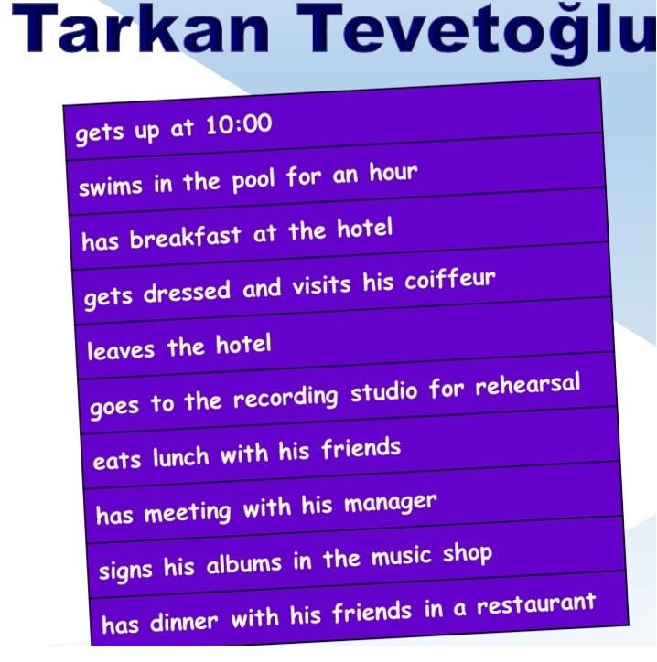Soru 11  Which question is answered in the image above?  A) When does he eat dinner?  B) Where does he have lunch?  C) What time does he leave the hotel?  D) Where does he have meeting with his manager?  E) What time does he get up?  Soru 12  Answer the question according to the text below.  Everyone wants to be happy in their life. Some find it easy to be happy. Others spend a lifetime for happiness and they can't find it. Some people think that money or having many expensive things will make them happy. But do they really make one truly happy? Now I have a little recipe that isn't hard to make but don't just bake it in the oven, spread it everywhere! Take a big mixing bowl and fill it with 2 cups of patience. Add 1 heartful of love and 2 handfuls of mindfulness. Put a big bottle of laughter and a handful of understanding. Sprinkle some kindness and faith. Mix them well. Serve anyone you meet.  What is the writer giving a recipe for?  A) A delicious chocolate cake  B) True happiness  C) A happy marriage  D) Success at school  E) How to prepare salad  CEVAPLAR: 1-A 2-C 3-D 4-E 5-B 6-A 7-B 8-D 9-E 10-E 11-E 12-B 13-D 14-D 15-B 16-B 17-D 18-B 19-B 20-C 21-B 22-C 23-E 24-E 25-C | 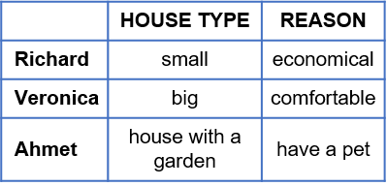Soru 13  Which of the following is not true according to the chart?  A) Veronica lives in a big house because it is comfortable.  B) Richard prefers an economical house.  C) Ahmet would prefer a house with a garden.  D) Ahmet and Veronica would prefer similar houses.  E) Richard and Veronica prefer different types of houses.  Soru 14  Choose the correct option to complete the dialogue.  Andy: What do you do in your ...... ?  Clare: I usually go out with my friends.  A) bed  B) house  C) classes  D) spare time  E) living room  Soru 15  Choose the correct option to complete the sentence.  We ...... often see each other because we ...... live in the same city.  A) can / don’t  B) can’t / don’t  C) don’t / can  D) are / do  E) aren’t / do  Soru 16  Choose the correct option that has the closest meaning to the underlined sentence.  Julia: I’m an author. I write adventure books. Teenagers really like my books. There are book fairs in different cities. I join them in March and November.  A) I publish books in March and November.  B) I attend book fairs twice a year.  C) Book fairs take place every season.  D) I visit book fairs quite often.  E) I go to book fairs twice a month.  Soru 17  Choose the correct option to complete the dialogue.  Dave: ...... join my garden party next week?  Susan: OK, I will be there.  A) Do you fancy  B) Do you mind  C) Do you like  D) Would you like to  E) Would you mind  Soru 18  Which of the following is the closest in meaning to the sentence given below?  John hates walking, so he always takes the bus to work.  A) John likes getting on the bus, so he doesn't walk to work.  B) John takes the bus to work everyday because he doesn't like walking.  C) John likes walking, so he always goes to work on foot.  D) He never goes to work because he doesn't like walking.  E) John prefers walking to taking the bus while going to work.  Soru 19  Choose the correct option to complete the sentence.  Luis : ...... does she wash her car?  Belinda: Once a week.  A) How long  B) How often  C) Which  D) What time  E) How high  Soru 20  Choose the correct option to complete the sentence.  She is bad at singing means ...... well.  A) She can sing a song  B) She hates singing  C) She can’t sing a song  D) She loves singing  E) She can be a singer  Soru 21  Choose the correct option to complete the sentence.  Mary lives with her parents so she can ...... see them.  A) rarely  B) always  C) never  D) hardly ever  E) seldom  Soru 22  Choose the correct option to complete the dialogue.  Diana: Do you get up early for school?  Hillary: Yes, I do.  Diana: ...... do your classes start?  Hillary: They start at 9:00 in the morning.  A) How long  B) How often  C) What time  D) Whenever  E) Where  Soru 23  Complete the dialogue with the correct option.  Shop Assistant: Which one would you like, sir?  Tom: ......  A) Why are you asking that?  B) Why don't you ask it to my wife?  C) You had better ask me later.  D) What do you think?  E) I prefer the blue one.  Soru 24  Which of the following is the closest in meaning to the sentence given below?  Jonathan is crazy about surfing the Net but can't stand chatting on the Net with people he doesn't know.  A) Everybody may not enjoy chatting on the Net with the people they don't know but Jonathan is fond of it.  B) Jonathan is keen on windsurfing with his friends but hates doing it with the people he doesn't know.  C) Jonathan can't surf the Net with the people he doesn't know but he can chat with his friends.  D) Surfing the Net is Jonathan's least favourite hobby but chatting with the friends on the Net is the most favorite one.  E) Surfing the Net is Jonathan's most favourite hobby but he hates chatting with the people he doesn't know.  Soru 25  Fill in the blanks with the correct option.  Hello, I’m a teacher. I want to give some information about my typical week. I teach at a primary school three days a week. I teach English to the paralysed students on Fridays. Once a week, I organize a speaking club with the students at a kindergarten. We sometimes play games. ....... because it is winter now and it is quite cold outside.  A) We always play outdoor games  B) We sometimes sing songs  C) We never go out of the class  D) We rarely tell stories  E) We often go out

