ELBISTAN VOCATIONAL AND TECHNICAL ANATOLIAN HIGH SCHOOL
2022-2023 EDUCATION YEAR 10th GRADE 1st TERM 1st ENGLISH WRITTEN EXAM
A | Writing: | Vocabulary: | TOTAL:
 | Reading: | Test:

Name:
Number: Time: 40 minutes
Class:

- WRITING

- Introduce yourself. ( Name, age, job, likes, dislikes etc. Write at least five sentences) ( 15 pts)

- Look at table and complete the sentences with “be going to”
( 5x3=15 pts)

 | Watch TV | Go online | Visit relatives | Do my homework | Go to Cinema
I |  |  |  | X
My Father | X
My Friends |  | X
Ali and Ayse |  |  | X
My Sister |  |  |  |  | X

- I ………………………………….. my homework.
- My father …………………………………….. TV.
- My friends ………………………………….. online.
- Ali and Ayse ……………………………………. their relatives.
- My sister ………………………………. cinema.
- READING

- Read the paragraph and answer the questions. (5x4= 20 pts)

My name is Serkan, and I’m from Bursa. I live in İstanbul with my parents and my brothers. I’m the youngest in my family. I turned 15 last month. My father is an doctor, and my mother is a nurse. They work at a hospital in the city center. I have got two brothers; Hasan and Mehmet. Hasan is 17, and Mehmet is 19. Hasan is very serious, and he always tells me what to do. I guess because he is the oldest. I go to a nice school in my neighborhood.
It is not too far from our home, and I really enjoy it. I have got a lot of friends there, and I enjoy studying. I really like Geography class, but I have some difficulty in Math. It’s not a problem, though because my brothers always help me, and I always get good grades from the exams. I love playing sports,
especially basketball. I’m the tallest player in the school team, and I usually play really well. My coach says one day I can play professional basketball! On the weekend, I spend a lot of time with my friends Sabri and Celal. We do everything together because we are really good friends.

1. Where is Serkan from? Where does he live?
2. How many people are there in his family? Who are they?
3. Where does he study? What is his favorite class?
4. Does he have difficulty in Math? What does he do about it?
5. What does he like doing in his free time?

- VOCABULARY
- Match the words with the pictures. (10x1=10 pts)

1. Schoolbag | 2.Desk | 3. Textbooks | 4.Breakfast | 5. Envelope
6.Glue stick | 7. Cookies | 8.Chess. | 9. Biking | 10. Map
A ___  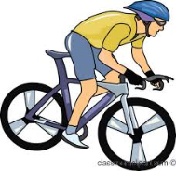 | B___ | C___  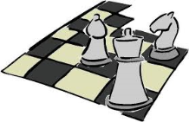 | D___  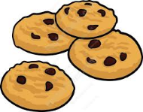 | E___  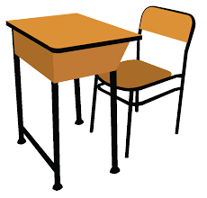
F___ | G___ | H___  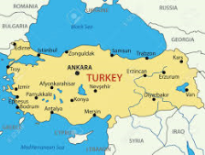 | I___  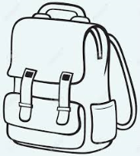 | J___

- Match the words with their Turkish meanings (10x1= 10pts)
Originally ___  Typical ___  Share ___  Campus ___  Opportunity ___  Elementary ___  Neighborhood ___  Successful ___  Invitation ___  Review ___ | 1- Davetiye  2- Gözden Geçirmek  3- Başarılı  4- Tipik  5- Başlangıç  6- Paylaşmak  7- Yerleşke  8- Aslen  9- Fırsat  - - Mahalle
https://www.sorubak.com
- TEST
Choose the correct option. (10x3=30 pts)

- What is your father’s job?
- He is forty seven years old.
- He is from France
- He is a teacher
- He likes playing football

- What is your mother’s name?
- She is a nurse.
- She likes listening to music.
- Her favorite color is blue.
- Her name is Angela

- When does your school finish?
- I have breakfast at 8:00 o’clock.
- It ends at 15:00 o’clock
- My school is in my neighborhood
- I have breakfast at school.

- How many classes do you have a day?

- I have got a lot of friends there.
- I like my classes.
- I have eight lessons a day.
- My favorite class is Math.

- A: Why don’t we do something together on Saturday?
B: …………………………………
A: Cool. I’ll call you on Saturday.

- Sorry, I am going to meet my friends on Saturday
- Good idea! I don’t have any plan for weekend.
- I really don’t enjoy going to cinema.
- You are going to visit your grandparents.

- I have / get up at 7:00 o’clock in mornings.
- I have lunch / dinner at 12:30 with my classmates
- After school I arrive home at 7:30 in the morning / evening.
- My favorite class is English / Geography because I like learning
about the Earth.
- I like studying Science / English because I like learning about foreign cultures
GOOD LUCK!

