A A

aa aa

B B B

bbbb





C C C c c ccc

MC900151171[1]

Ç Ç Ç çç ççç



CA05SGXTCAV0BAN5CA248303CAIKD8LYCAX2K73BCAAVRF09CAUBDL0ICATWXC4ACADQG04ICAOO53LNCA8FO8M7CA211S1LCACF2XEKCAWC79N0CAY3NGZECAPKA6UDCA5OCNG3CAKMSQN3CA9Y6YD2CAHIAK8E

D D dd dd



E E E

eee eee eee

MC900310154[1]

F F F fff ffff

MC900019699[1]

G G G g g g g

MC900441395[1]

Ğ Ğ

ğ ğ ğğğ

MC900290861[1]

H H H h h h hhh



II I I I

ı ı ıı ı

MC900344949[1]

İ İ İ iii iii





J J J J

j j jj jjj



MC900353973[1]

K K K k kk

MC900440645[1]

LLL

lll llll lllll

MC900437980[1]

*M M M mm mm*



N N N

nn nnnn

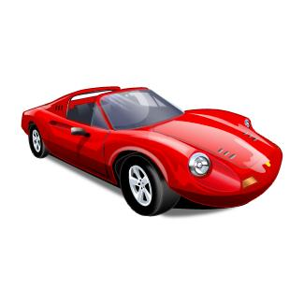

O O oo ooo



Ö Ö

ö ööö



P P P

p p p ppp



RRR RRR rr r rrr

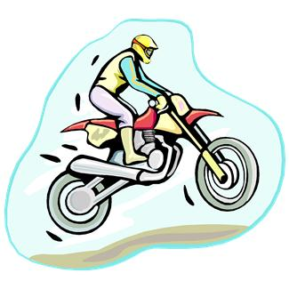

S S S

s s sss



Ş Ş Ş

ş ş şşş



T T T

t t t

MC900233159[1]

MC900250579[1]

U U UUU

u uuu



Ü Ü Ü ü üüü



V V V vvvv v

MC900331566[1]

MC900251021[1]

YY Y

y yy yyy



Z ZZ

z zzz



Zeliha BUHUROĞLU

Ekim-2011

derskitabicevaplarim.com