derskitabicevaplarim.com
HELLO !😊
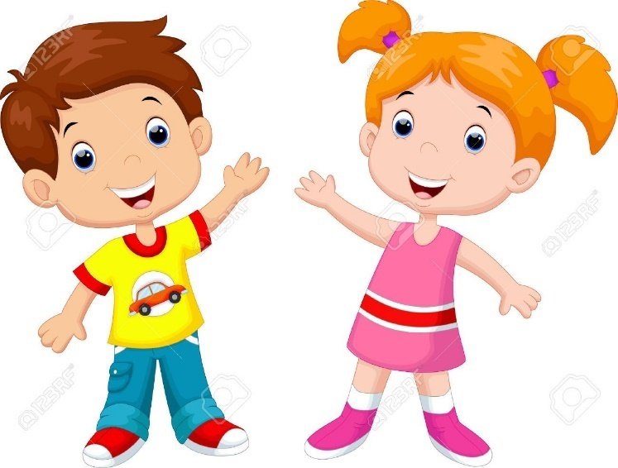

Hello!What’syour name?
My name is Alice.
Hi!What’syour name?
My name is Mark.
What is your name?
My name is_______.
Nice tomeetyou.
Nice tomeetyoutoo.

Esra Çiğdem Sayar

