 |  |  |  | 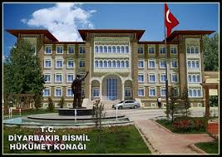 | 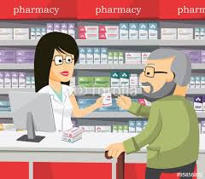
 | Public buildings
 | 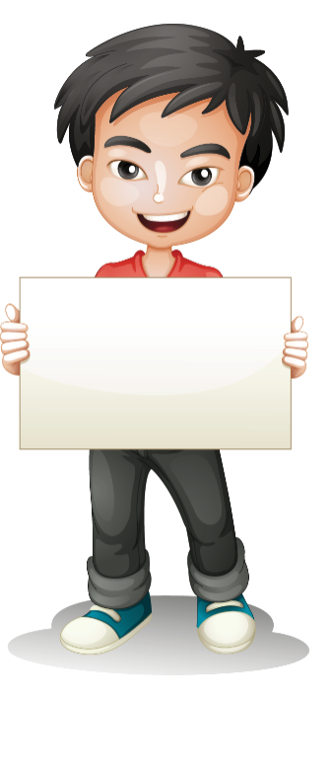  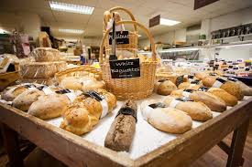 | 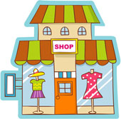 |  | 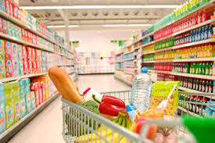 | 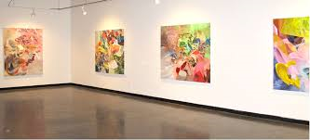
 | 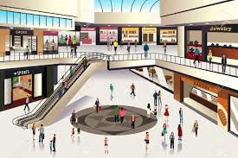
 | 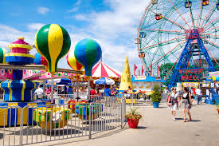 | 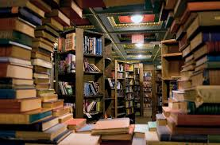 |  | 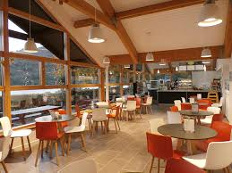 | 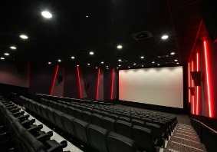
shopping mall
zoo
cinema
city hall
amusement park
art gallery
pharmacy
shoe shop
boutique
bakery
grocery
gym
bookstore
car park
café
fire station
florist’s
greengrocer’s

Fill in the blanks with the correct public buildings.  I went to ___________________. I bought some bread  She will go to ___________________a. She will watch Shrek 3  They went to ______________. They wanted to see wild animals.  My father went to ____________. He wanted to buy some clothes  You should go to ________________. You should buy medicine.  I went to ___________________. I bought some flower for mum.  We will go ________________tonight. We want to see a new play.  David will visit ___________________. He wants to buy a painting.  I need to go to ___________________. I will buy some books.  My mother always goes ___________________. She wants to buy fresh fruit and vegetables  My sister always meets with her friends at the ___________________. She has some dessert and drinks.  They will be at the ___________________ after school. They will study in a quiet place.  We went to ___________________. We reported the robbery.  He usually goes to ___________________with his friends at weekends. He wants to have some fun.  Mr. Hawk was in the ___________________. He bought some cookies.  She went to ___________________.She wanted to buy a new dress for her birthday party.  My little brother always wants to go ___________________. He wants to buy some candies.  Adam goes _____________ every day. He wants to have a fit body.  My mum and I went to a/an ___________________yesterday. We bought two pairs of shoes.  Jane was in the ______________yesterday. She sent some letters.  My father went to ___________________. He paid the bill.  Cenk goes ________________ on Saturdays. He buys new clothes.  I went to _____________yesterday. I bought two tickets for Paris.  She usually goes ____________ on Sundays. She buys newspapers. |  |  | A ) Make sentences in the past simple tense  1 The cat / climb / the tree ________________________________________________  2 Daisy / describe / their house _______________________________________________  3 They / paint / the door _______________________________________________  4 She / clean / the table / in the kitchen _______________________________________________  5 We / study / English / together _______________________________________________  6 They / like / the dancers _______________________________________________  9 I / not / enjoy / the picnic _______________________________________________  10 Hakan / not / help / his father / yesterday ________________________________________________  11 The teacher / ask / us / a lot of questions ________________________________________________  12 It / not / rain / last month ________________________________________________  13 I / not / watch TV / on Saturday ________________________________________________  14 you / enjoy / the film ? _______________________________________________?  15 you / brush / your teeth / this morning / ? _______________________________________________?  16 they / help / you / in the shop / ? _______________________________________________?
Cafe -Florist's –Pharmacy- Bakery- Green grocer- Fire station - Shopping mall
1. I went to the ________________ to buy bread.
2. She went to the ________________ to buy flowers.
3.He usually goes to the _____________ to buy fruits.
4. I saw the fire and called ______________________ immediately.
5. I always go to the ________________ to buy medicines.
6. My friend always goes to a ___________________ to buy clothes.
7. I usually go to a ____________ to drink tea.
sale café documentaries cash book size tired
Don’t pay by credit card, pay in __________, please.
Shoes are on __________________, let’s buy them.
I watch _____________________ about wildlife
How much is this ___________________ ?
I need a bigger _______________.
I had a bus day, I am _____________ .
You can drink tea at a __________

example : He went to the city hall to pay his bills
butcher / meat ____________________________________________________
boutique / clothes _________________________________________________
pharmacy / medicine_______________________________________________
bookshop / dictionary_______________________________________________
greengrocer / carrot________________________________________________
florist’s / flower ____________________________________________________
Complete the names of the places.
fire ______________
shopping ___________
post _____________
city ________________
amusement _________
art ________________
sports ______________
bus ________________

What did you do yesterday? ( listen to music )
……………………………………………………………………………………………………
What are you doing now? ( study English )
…………………………………………………………………………………………………
What will you do tomorrow? ( go to cinema )
…………………………………………………………………………………………………
What do you do everyday? ( watch TV)
…………………………………………………………………………………………………

Write Customer or Salesperson.
Who says these sentences in shopping?
1 Is there a discount? _______________
2 You can buy and get one free _______________
3 How much is it? _______________
4 You will pay the half price _______________
5 It’s on sale _______________
6 Here is money _______________

v

derskitabicevaplarim.com
1 I go to the cinema a to buy bread  2 I go to the post office b to buy fresh vegetables  3 I go to the police station c to travel by plane  4 I go to the department store d to watch a movie  5 I go to the airport e to do shopping  6 I go to the grocery f to have fun  7 I go to the bakery g to meet my friends  8 I go to the cafe h to be fit  9 I go to the sports center i to talk to the policeman  10 I go to the amusement park j to send a letter | 1
 | 2
 | 3
 | 4
 | 5
 | 6
 | 7
 | 8
 | 9
 | 10

FİİLLERİN 2. HALLERİNİ YAZIN (V2)
Meet: M See: S Am/Is: W
Go: W Get up: G Drink: D
Buy: B Study: S Eat: A
Visit: V Do: D Help: H
Watch: W Sleep: S Come: C
Have: H Want: W Send: S
Ex : Ece / London- Tower Bridge >>> Where is Ece ? She is in London. What will she do there ? She will visit Tower Bridge
1. Murat / Berlin – City Hall.___________________ ____________________________________________________________.
2. Ayşe / Rome – The Colosseum.___________________________________________________________________________.
3. Hakan / Sydney –Sydney Opera House._____________________________________________________________________.
4. Merve / Paris – Eiffel Tower._____________________________________________________________________________.
5. Murat / New York – Statue of Liberty______________________________________________________________________.
Fill in the blanks with the appropriate words or phrases.
1. My mum goes to ________________ to see new paintings.
2. He went to _____________________ to build his muscles.
3.You must call _______________ if there is a fire in your neighborhood.
4. You can buy everything in a/an ___________________
5. My father was at the ___________________ yesterday because he was ill
6. You should buy muffins, bagel and bread at the _______________-
7. Jenny went to ______________ to drink something.
8. You should go to the _____________ if you need medicine.
art gallery
neighbourhood
shoe shop
stationery
pharmacy / chemist’s
travel agent

Osman wen to the ……………………….to buy some bread. bakery / pharmacy / cinema / green grocer
Nick went to the bookstore to ………. some books. buy / drink / lend / write
I want to see wild animals. We should go to the …… art gallery / zoo / theatre / green grocer
I need to buy a new jacket. Shall we go to a …… ? hospital / city hall / florist’s / boutique
Merve …………… up at seven o’clock every morning. get / take / watch / goes to bed
HangiSoru.com often ………….. her friends at a cafe. washes / eats / meets / meat
My friends ……….. Eiffel Tower last summer. broke / visited / swam / bought
The fridge is empty. Let’s ………………. . go shopping / take a taxi / watch a film / read boks
I went to the mall and …………….. new bags. To buy / buys / buyiing / bought
I went to the …………………. to buy some CD’s sunglasses / cafe / school / music store
If you like paintings, go to the ………….. art gallery / stadium / technology store / pharmacy
7. sınıf 8. ÜNİTE PUBLIC BUILDINGS WORKSHEET / HAYRİ HOCA GEBZE derskitabicevaplarim.com

