derskitabicevaplarim.com8.SINIF İNGİLİZCE 2.DÖNEM 2.YAZILI

1.Aşağıdaki cümleleri eşleştiriniz.(6*1=6 puan)

1.Erdem is working in the lab. (……………..)
2.The researchers are in the excavation centre.(……………..)
3.My sister is interested in science.(……………..)
4.Tarık is looking into the sky through a telescope.(……………..)
5.Thomas Edison was an American inventor.(……………..)
6.Cüneyt is surfing the Net.(……………..)
A.He’s exploring the craters on the Moon.
B.He invented the electric light bulb.
C.They’re looking for some fossils.
D.He is searching fort he famous inventors.
E.He is making robot for his science Project.
F.She likes reading magazines about it.

2.Aşağıdaki kelimeleri uygun resmin altına yazınız.(5*1=5)

safety goggles | light bulb | Bunsen burner | vaccination | fossil
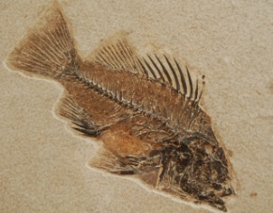
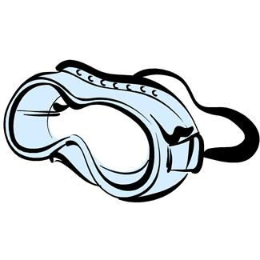
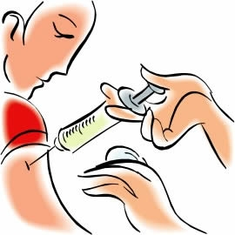

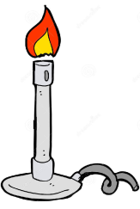

5)
4)
3)
2)
1)

3. Match the household chores with the photos. (7x1= 7 Points)
1) do the laundry | 6) cook the meals
2) do the grocery shopping | 7) feed the cat
3) vacuum the floor | 8) set the table
4) do the ironing | 9) take out the garbage
5) load/empty the dishwasher | 10) hang out the clothes

----------------- ------------------- ---------------------- --------------------
-------------------- ------------------------ -----------------------

4. Match the pictures with the definitions. (5x1= 5 Points)
rafting | -motor racing | Hang-gliding | bungee-jumping | trekking
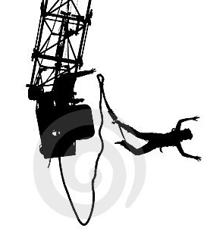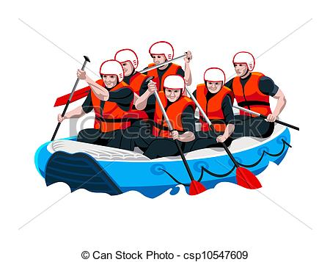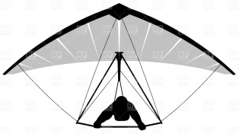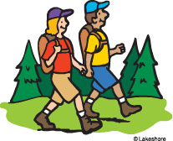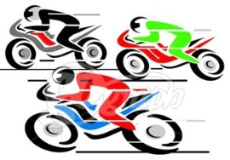
1._______________ 2._____________ 3._______________ 4.______________ 5.______________
5. Are these a “discovery” or an “invention”? Write. (6x1= 6 Points)
1) Telephone ……..................................... 2) Electric light bulb ……………………….
3) Compass ………………………………. 4) Phonograph ……………………………..
5) Electricity …………………………….. 6) X-rays ………………………………….
6. Match the sentences with the given pictures. (4 puan)
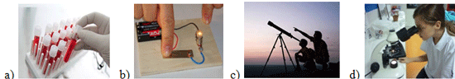
__1. She is in the school lab. She is looking some specimens under the microscope.
__2. He is doing an experiment. He is using test tubes to observe different chemical reactions.
__3. They are looking into the sky through a telescope.
__4. She is making a model regular bulb.

7.What natural disasters are they? Read and find.(3 puan)avalanche —forest fire – flood

1. The water is two metres deep in some parts of the town. And the situation won’t get any better
until the rain stops. ...............................................

2. The flames swept through the dry forest, destroying thousands of hectares of trees. .....................
............

3. We were skiing in Kartalkaya when the snow on the slope above us started to slide down towards
us. ...............................................

9.Look at the chart and fill in the blanks. (5 puan)
 | Cook the meals | Vacuum and mop the floors | Make the beds | Sweeping the garden | Doing grocery shopping | Do laundry | Feed the pets
Mum | ✓ |  |  |  |  | ✓
Dad |  |  |  | ✓ | ✓
Sally |  | ✓ | ✓
Sue |  | ✓ |  |  |  | ✓
Mark |  |  |  |  |  |  | ✓
derskitabicevaplarim.com

